Doing Research Inclusively. Co-production in Action.

Booklet 1

Starting research together

www.unsw.edu.au

Contents
About these booklets 1
Booklet 1 Starting the research 4
Questions to think about 6
Co-production. How we work together 9
Why co-production is important 10
Researcher and co-researcher roles 11
Access needs 13
The next booklet 14

About these booklets

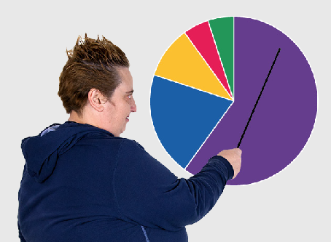
These booklets are a summary of Doing Research Inclusively: Co-production in Action.

Research is when we gather information to learn more about a topic.

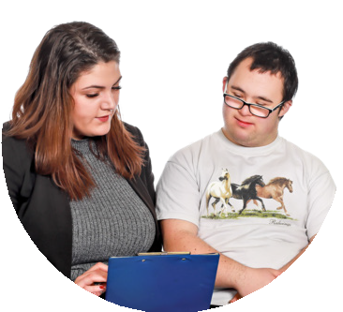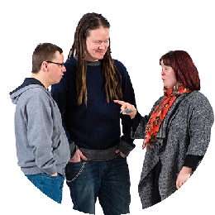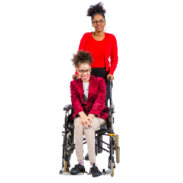Researchers at universities can work together with lots of different people

- People with disability

- Disability organisations and service providers

- Support workers

- Family and friends

We call these people co-researchers.

Co-researchers are people involved in the research who are not academic researchers.

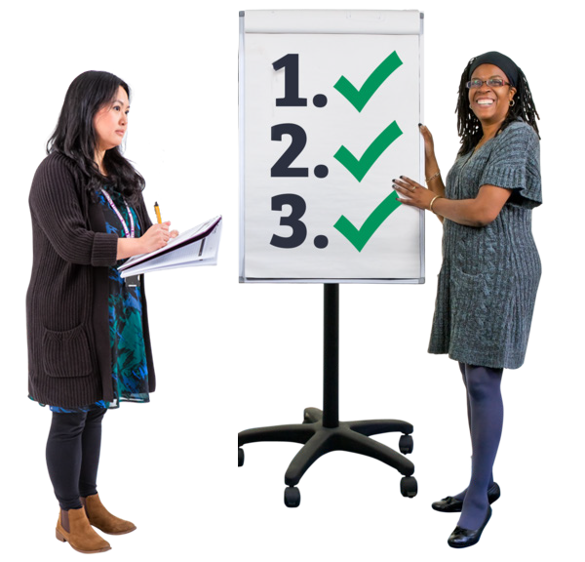Co-production means doing research together.

People with disability are included in the research process.

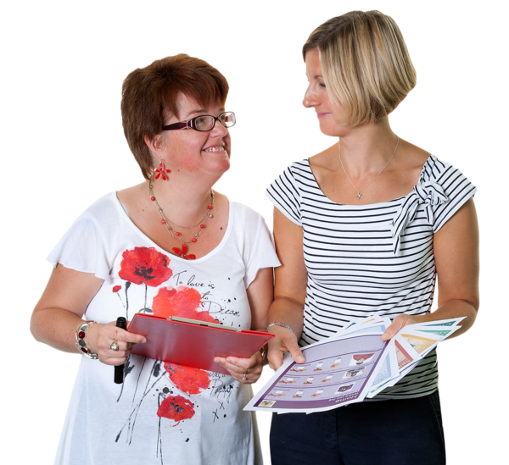This booklet talks about how we work together to do research.

There are 6 different booklets

1

2

3

4

5

6

Starting research together

- Planning research together

- Doing research together

- Understanding data together

- Sharing what we learnt together

- Talking about our research together

If you want to know more about co-production you can look at another booklet we made.

It is called Inclusive Research. A guide to doing research with people with disability.

Booklet 1 Starting the research

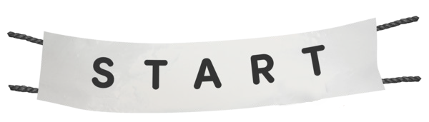This step is called

Starting the research.

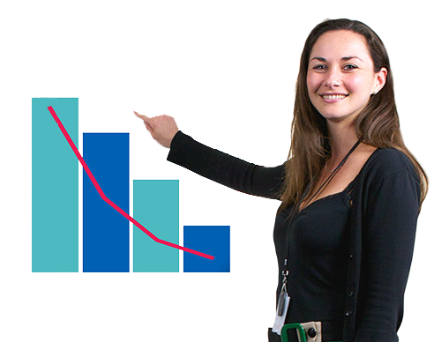The first step is to decide

- What to research

- Why it is important for people with disability

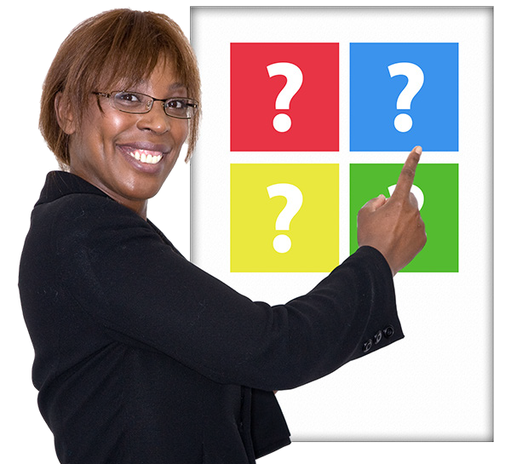There are different ways to do this.

We might find something that has not been researched before.

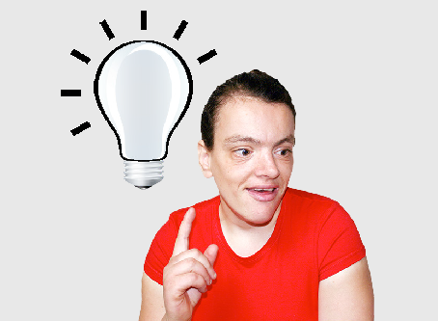
People with disability might have an idea of what we should research.

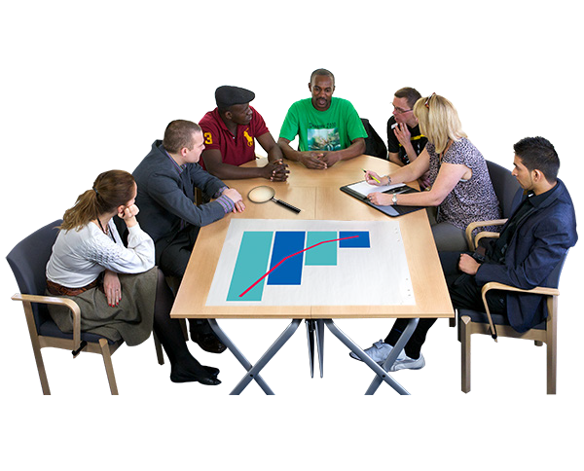Disability organisations might have an idea of what we need to learn more about.

Places who give money for research might have a topic they would like people to research.

These are called funders.

Questions to think about

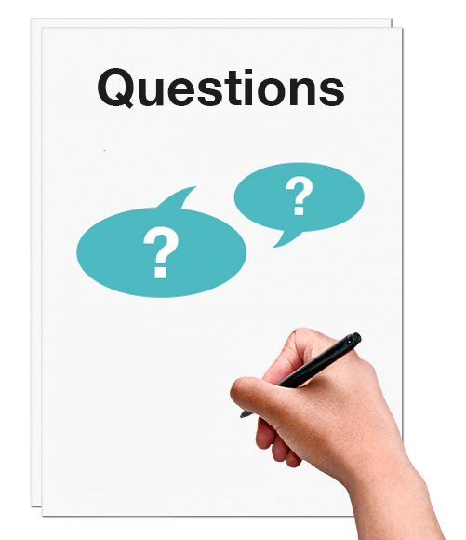When we are deciding on the research topic we need to think about some questions.

How do we know that the research idea is important to people with disability?

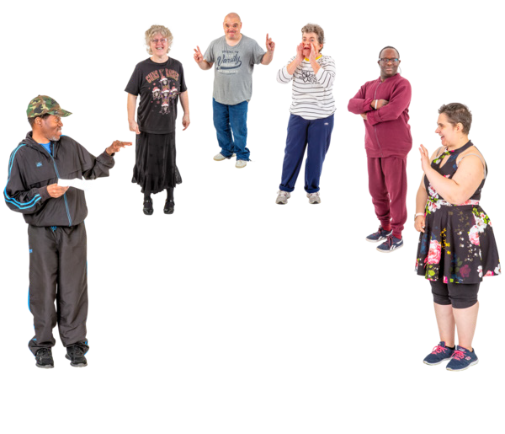When researchers have a research idea they need to ask people with a disability about it.

This is so they can say if it is a good idea.

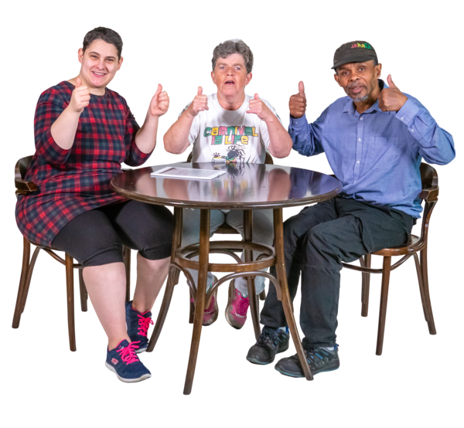The researchers and people with disability need to agree about the research idea.

How can everyone work together?

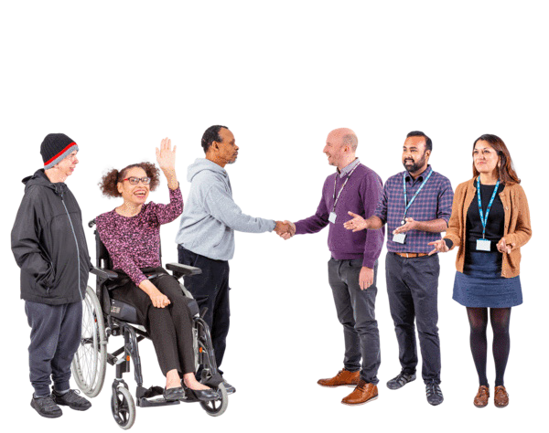It is important that researchers work together with

- People with disability

- Disability organisations

We call this a research partnership.

It takes lots of time and hard work to make research partnerships.

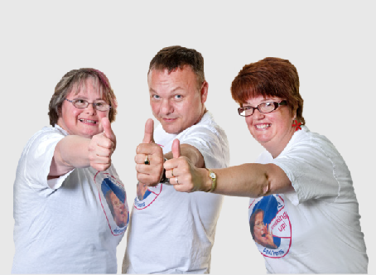
It is not easy but it is really important to do.

How will the research idea be good for people with disability?

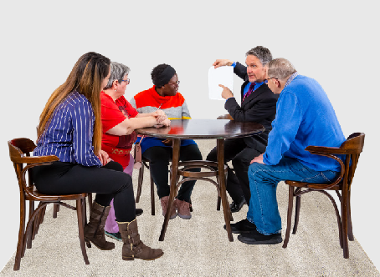
It is important to bring research ideas to

- People with disability

- Disability organisations

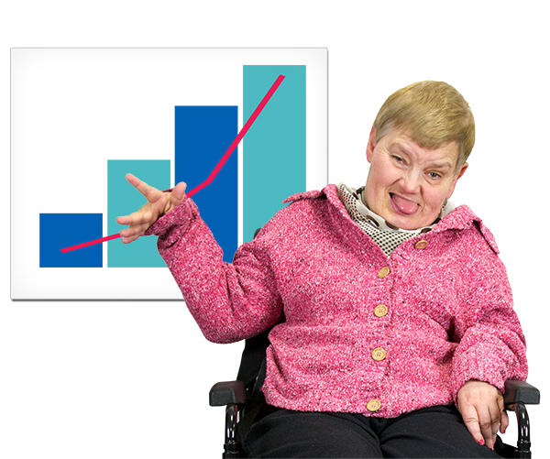This will help to find out if the research idea is good.

Co-production. How we work together

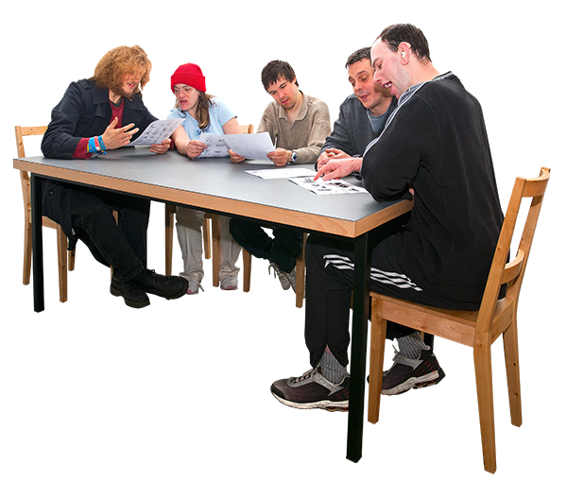Co-production means the research that people do together.

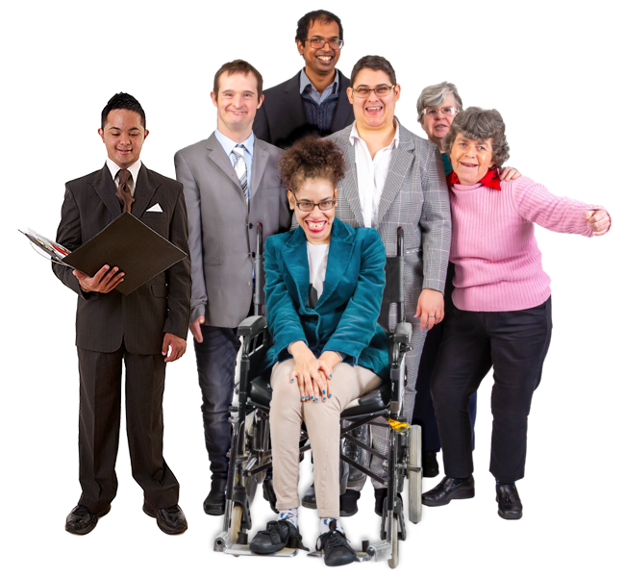We make sure that we respect others when we research together.

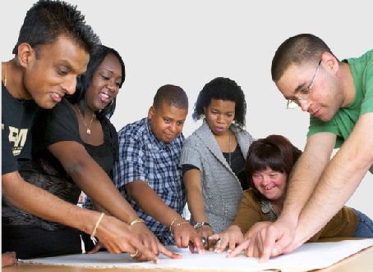
We make sure what we research together will be good for everyone.

We need to make sure that everyone agrees on how we do things.

Why co-production is important

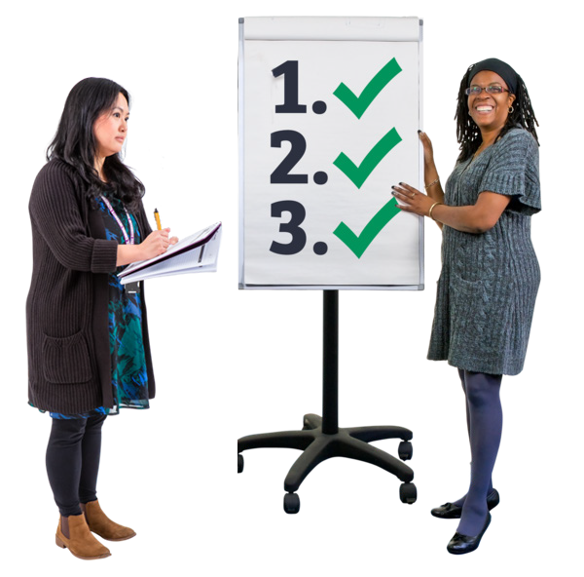There are lots of good things that happen when we do co-production.

Co-production helps connect

- Universities

- People with disability

- Disability organisations

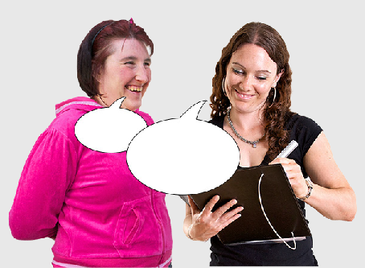
Co-production makes sure that research is about what is important for people with disability.

Researcher and co-researcher roles

Researchers and co-researchers have different roles in research.

Researcher roles

The researchers check if the topic has been researched before.

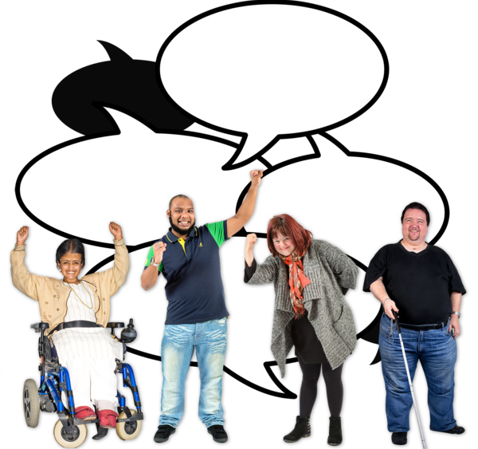The researchers must understand that the voice of people with disability is important.

The researchers make sure that they have good partnerships.

The researchers work together with the
co-researchers to work out what jobs they will each do.

Co-researcher roles

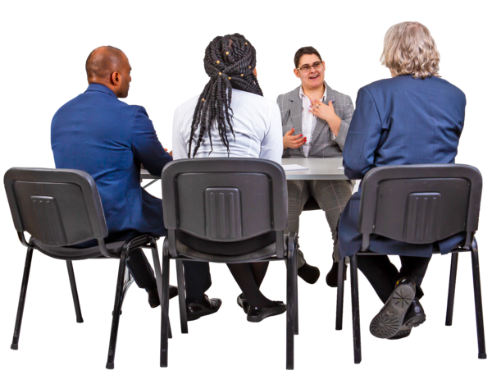The co-researchers have lots of jobs in this step. Co-researchers bring lived experience.
This is when people with disability know things because they live with a disability.

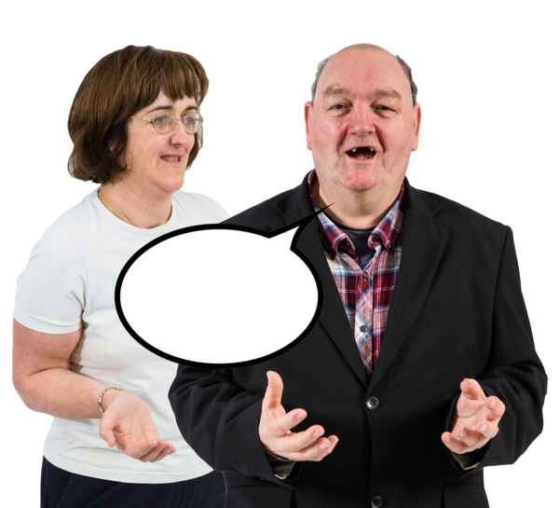The co-researchers talk about what the issues are for people with disability.

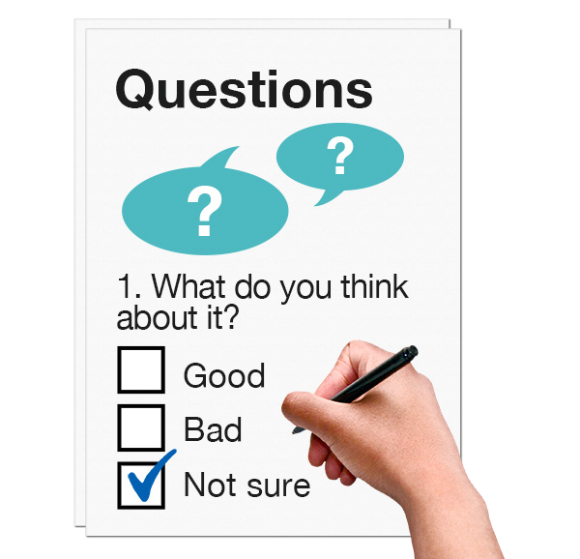The co-researchers make sure the research questions are about the lived experience of people with disability.

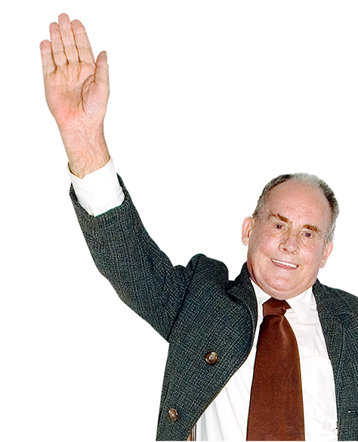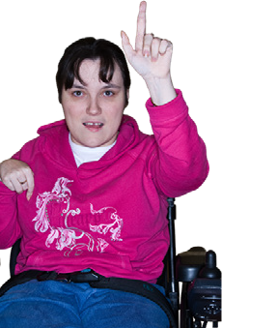Everyone comes up with an idea of what to research together.

We call this a co-initiated research topic.

Access needs

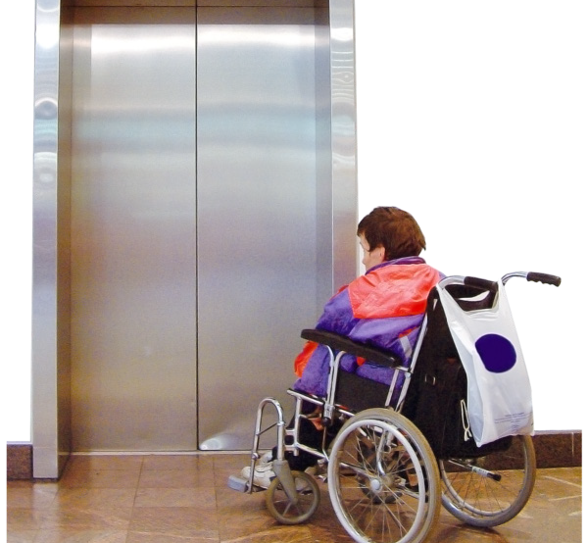People with a physical disability must be able to access places where the research is done.

The team decides which documents should be in Easy Read.

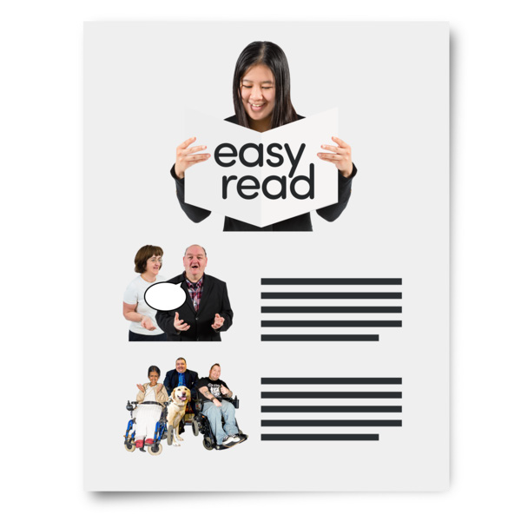Make sure that

- There is money to make our documents Easy Read
- Some members of the research team do an Easy Read course

The next booklet

Booklet 2 will talk about the next step of co-research.

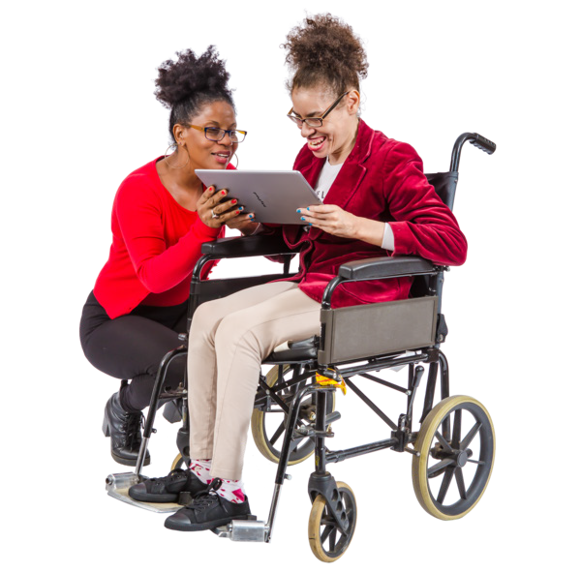The next step is called

Planning research together.

This guide was made by the Disability Innovation Institute at UNSW.
Council for Intellectual Disability made this document Easy Read. CID for short. You need to ask CID if you want to use any pictures in this document.
You can contact CID at business@cid.org.au 14

For more information contact:
Phone: 02 9385 9114
Email: diiu@unsw.edu.au
Website: www.disabilityinnovation.unsw.edu.au

