Doing Research Inclusively. Co-production in Action.

Booklet 2

Planning research together

www.unsw.edu.au
1

Contents

About these booklets 1

Booklet 2 Planning research together 4

Questions about planning the research 5

Planning for co-production 8

Big things to think about when planning research 12

Things we can do together when planning research 15

Working together makes our research better 17
The next booklet 18

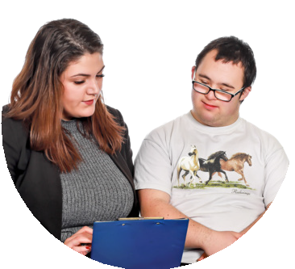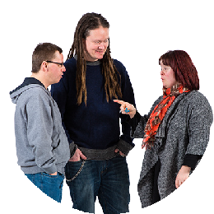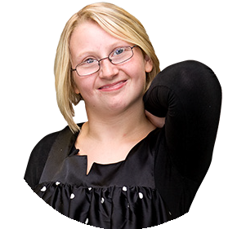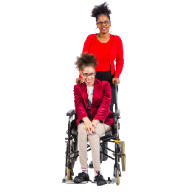About these booklets

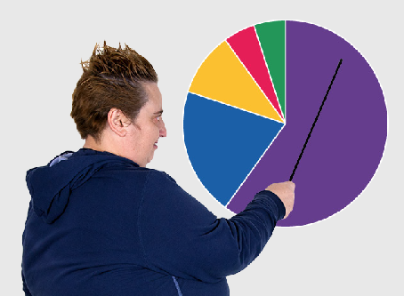
These booklets are a summary of Doing Research Inclusively: Co-production in Action.

Research is when we gather information to learn more about a topic.

Researchers at universities can work together with lots of different people

- People with disability

- Disability organisations and service providers

- Support workers

- Family and friends

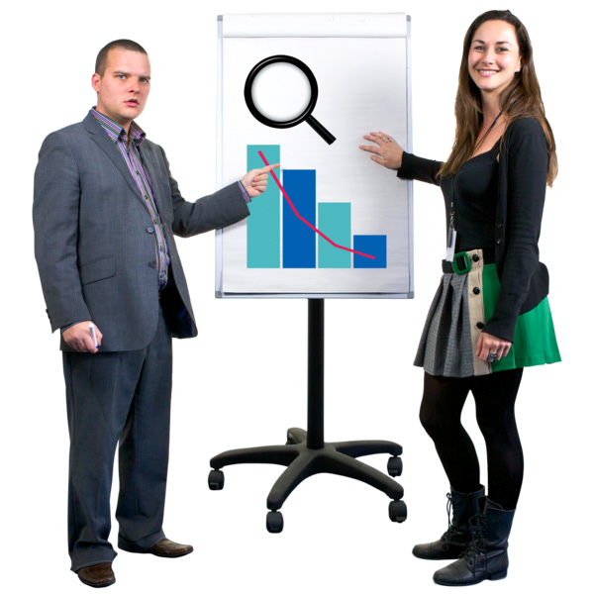We call these people co-researchers.

Co-researchers are people involved in the research who are not academic researchers.

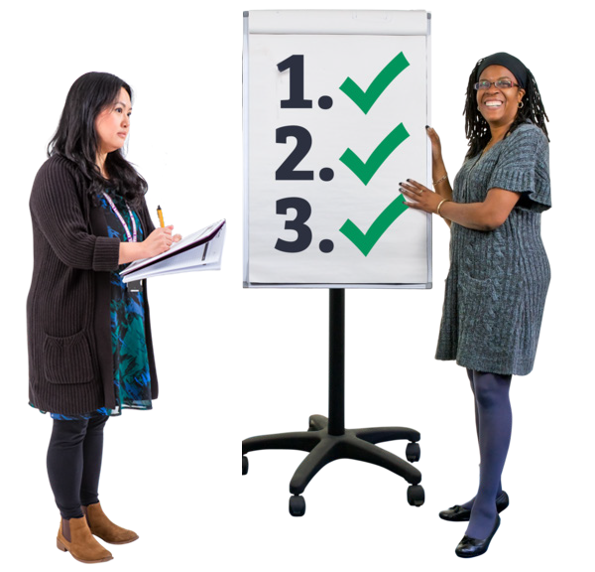Co-production means doing research together.

People with disability are included in the research process.

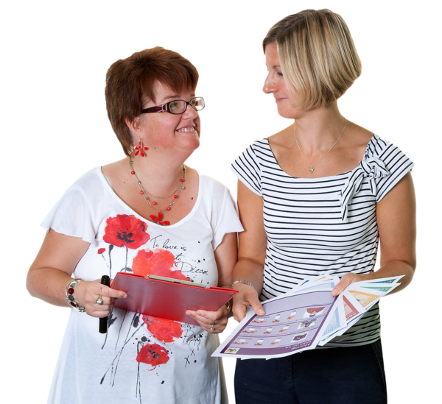This booklet talks about how we work together to do research.

There are 6 different booklets

1

2

3

4

5

6

- Starting research together

- Planning research together

- Doing research together

- Understanding data together

- Sharing what we learnt together

- Talking about our research together

If you want to know more about co-production you can look at another booklet we made.

It is called Inclusive Research. A guide to doing research with people with disability.

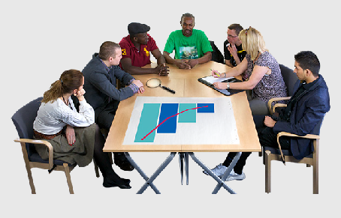
Booklet 2 Planning research together

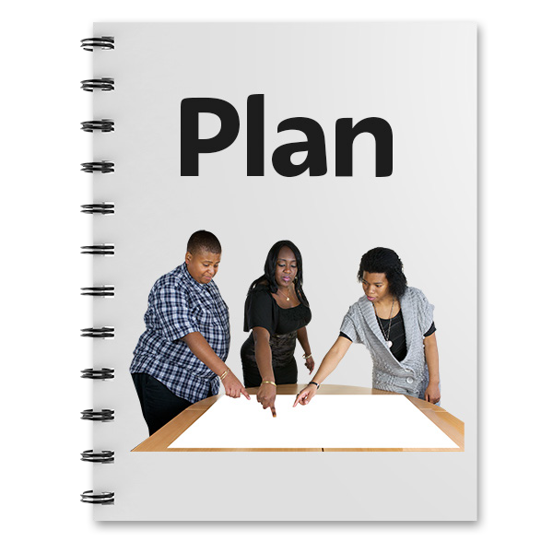This step is called

Planning research together.

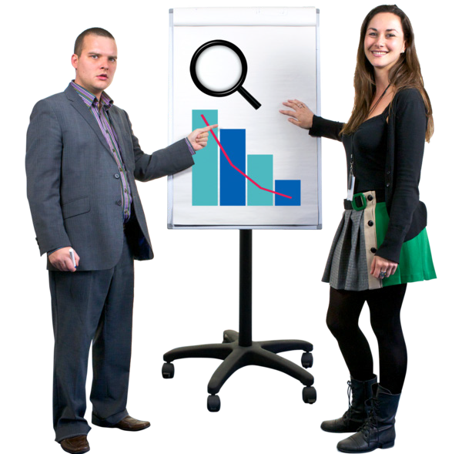Planning is very important when we do research.

It helps the team know what to do.

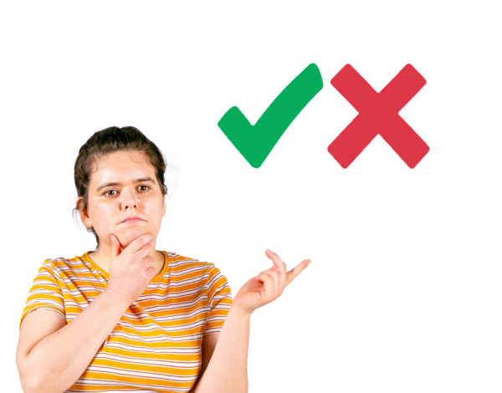There are lots of decisions to make when planning research together.

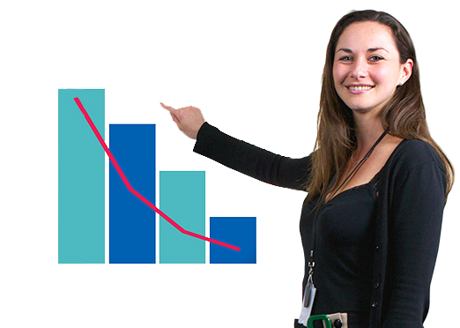We need to choose what we want the research to look like.

We need to decide how we will work together in co-production.

Questions about planning the research

These are some questions to think about when we are planning how to do our research.

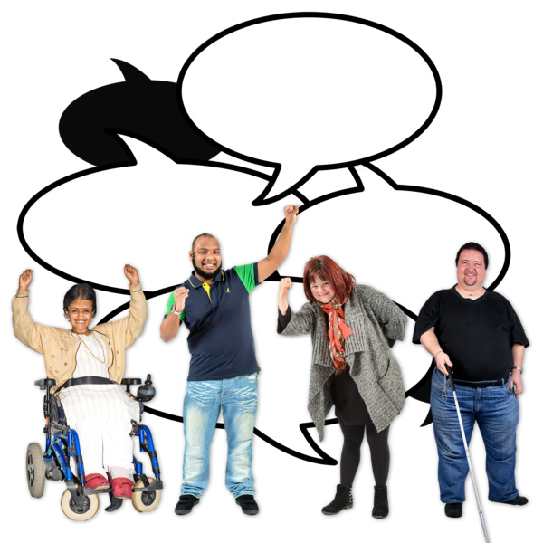What have other people already said about the research topic?

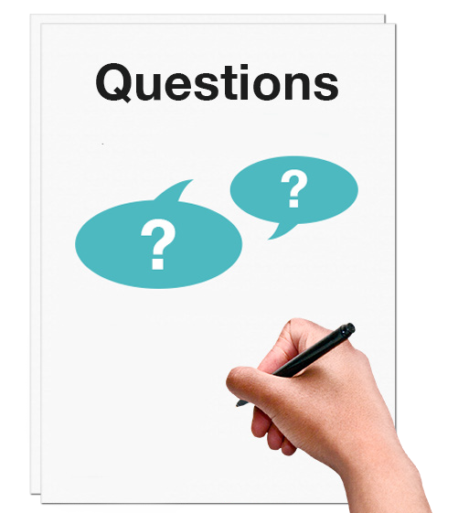What are the questions we want to answer?

How do we get the information we need to answer the questions?

Who can give us the information we need?

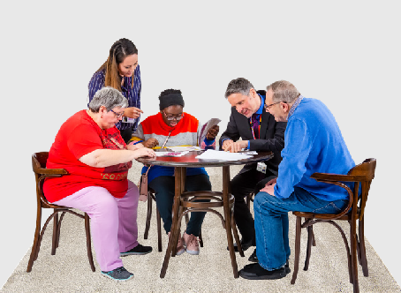
How many people should we talk to?

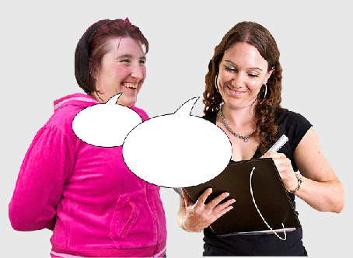
How do we find the right people to talk to?

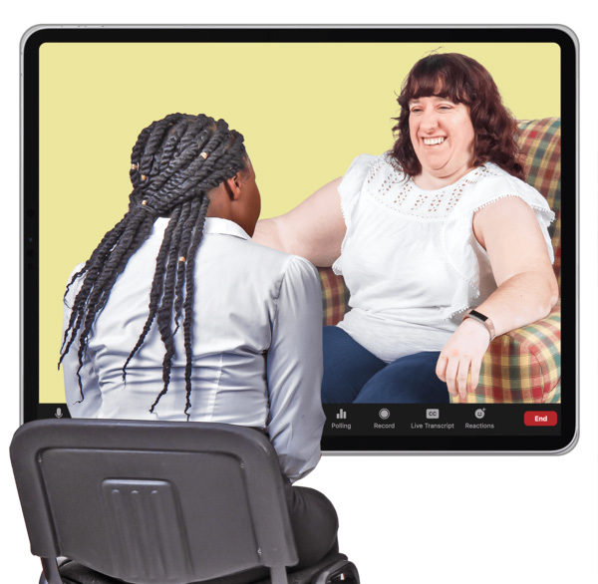What do we ask people?

How do we ask questions so that people understand?

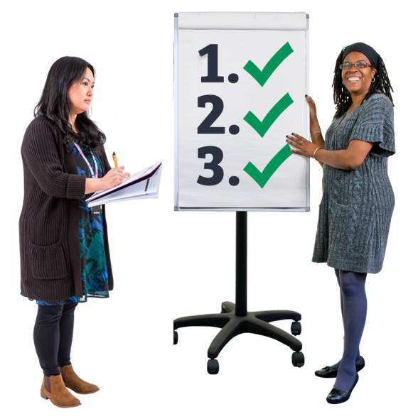How do we make sense of what everyone tells us?

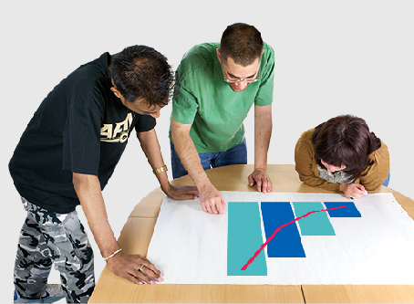
Who needs to hear about what we find?

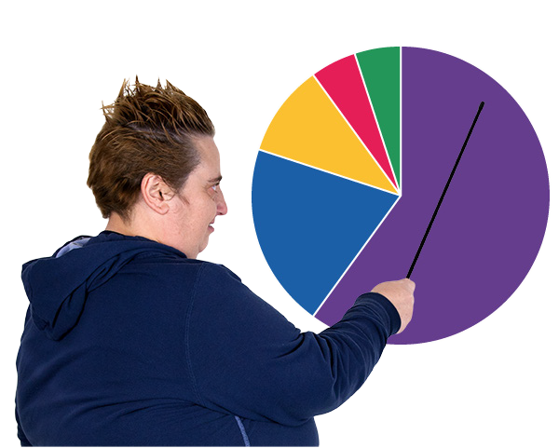What are the different ways we can record what we find?

For example

- Easy Read

- Report

- Podcast

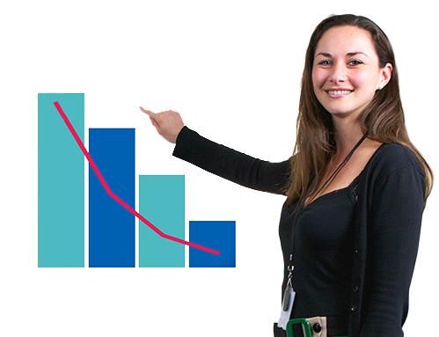What are other ways we can share what we find? For example
- Talk to the minister

- Hold a forum

- Go to a conference 7

Planning for co-production

There are some things to think about before we start doing co-production.

?

We need to agree how we are going to make decisions together.

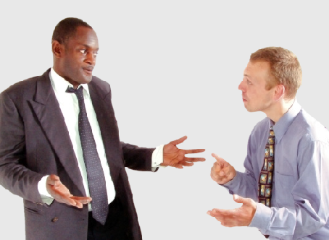
We need to plan what to do when team members have different opinions about the research.

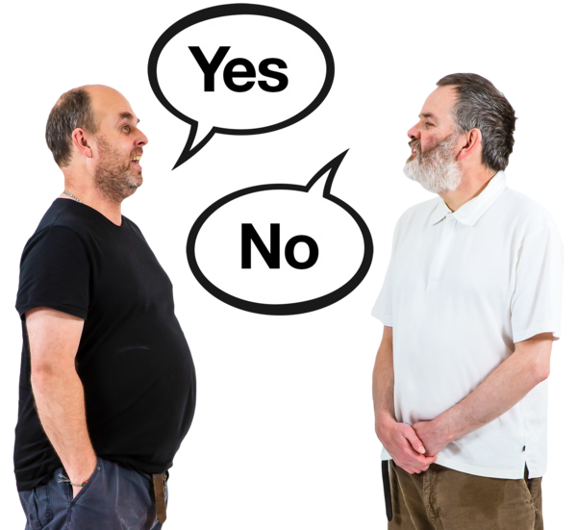We need to think about dealing with conflicts of interest.

A conflict of interest is when something stops you making a fair decision in the research.

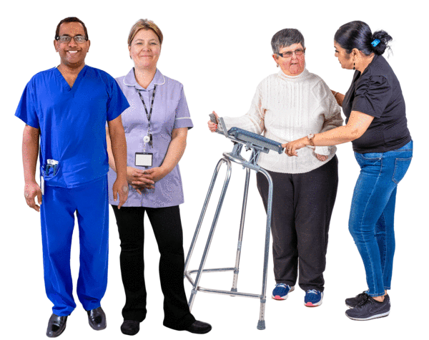We need to decide what each team member will do.

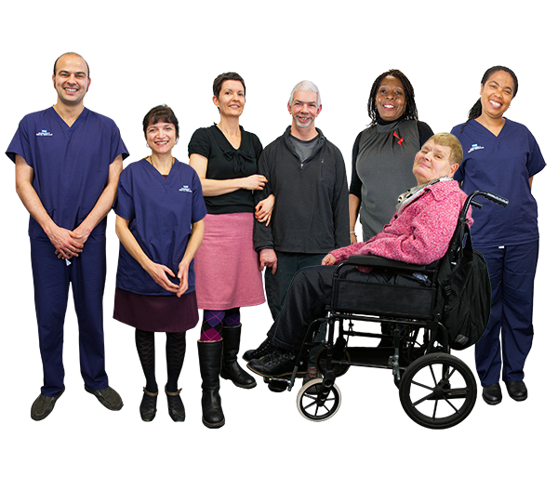It is okay for people to change their roles during the research.

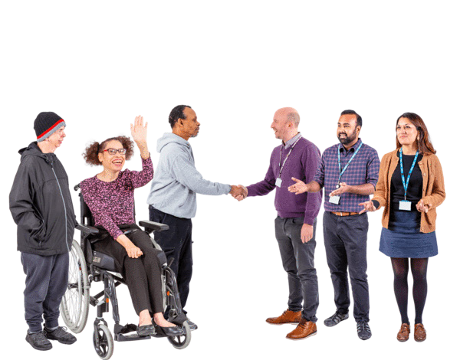But it is important at the start that we talk about what each of us will do.

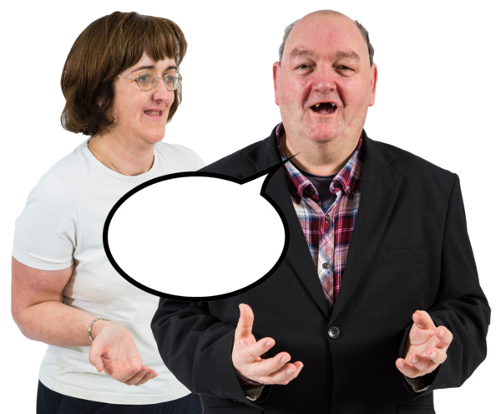Everyone in the research team has a right to have their say.

We need to think about what kinds of support will help people to do a good job.

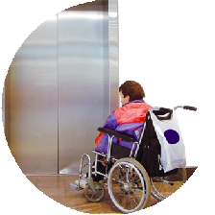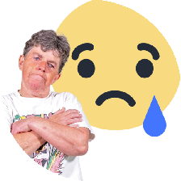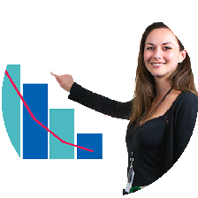People might need support with different things such as

- Wheelchair access

- Easy Read

- Understanding what other people mean

- Doing the research part of the job

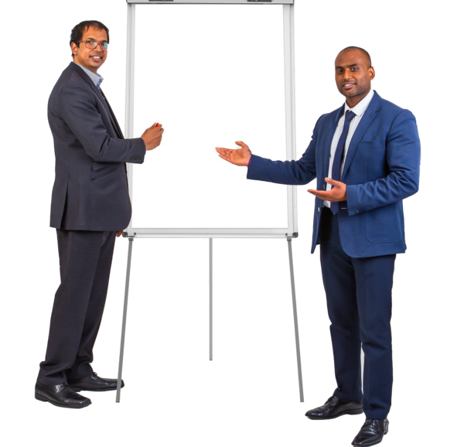Everybody in the team needs to feel safe.

safe

People might have different ideas about what is safe and unsafe.

For example, safety can be about

- Places where people go

- Things people say

- Things people hear

Big things to think about when planning research

Who else should be involved in doing the research?

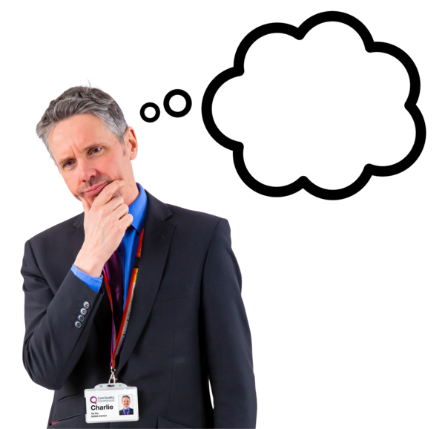Is there anyone who has a big interest in this area?

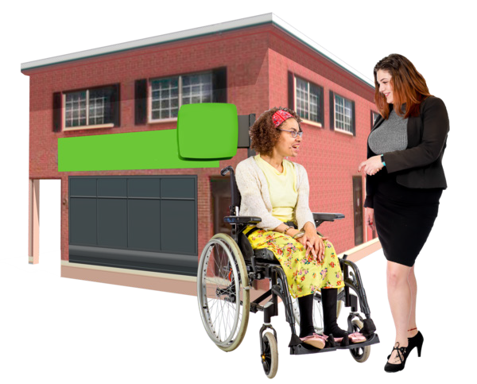Which disability organisations could help with the research?

How much will our research cost?

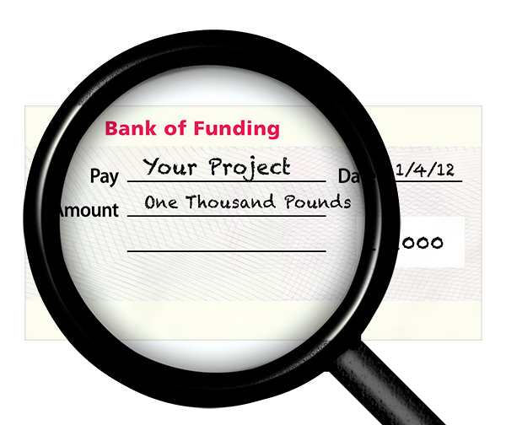Where will we get the money from?

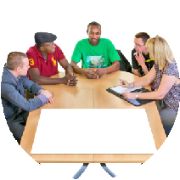Make sure we have money for co-production. For example
- Payment for co-researchers

- Training for team members

- Easy Read

- Meeting costs

- Computer programs or equipment

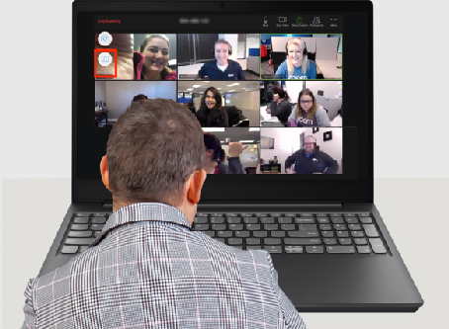
What are our training needs?

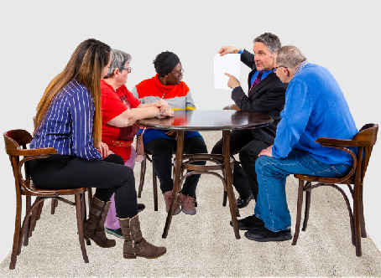
What skills do we need to learn to do the research?

What training will help us to get those skills?

Things we can do together when planning research

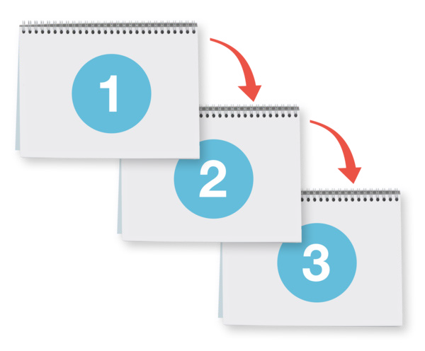These are the things we might do during this step.

Write funding applications together.

Funding applications

Funding applications are letters you write to get money for your research.

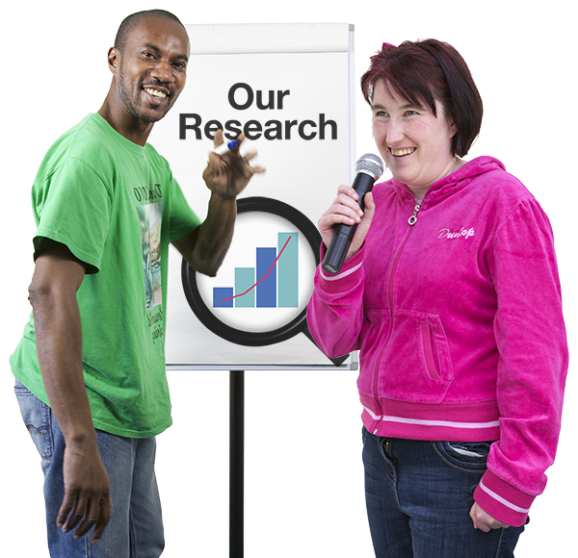Talk about how co-production will work in our team.

Make agreements about how we will work together.

Agreement means when we all say yes to how we do things.

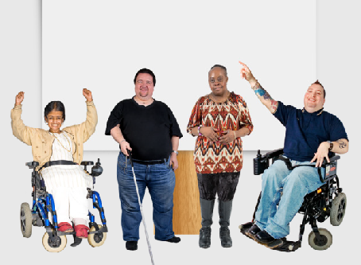
Reach out to other disability groups.

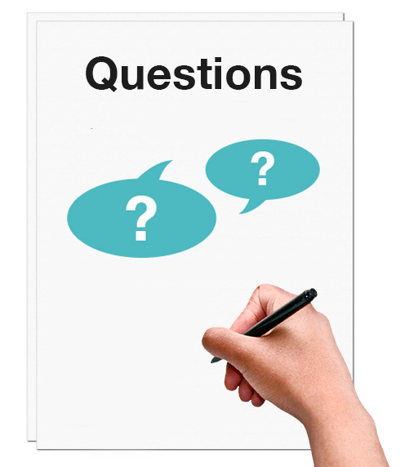Ask questions that are important to people with disability.

Working together makes our research better

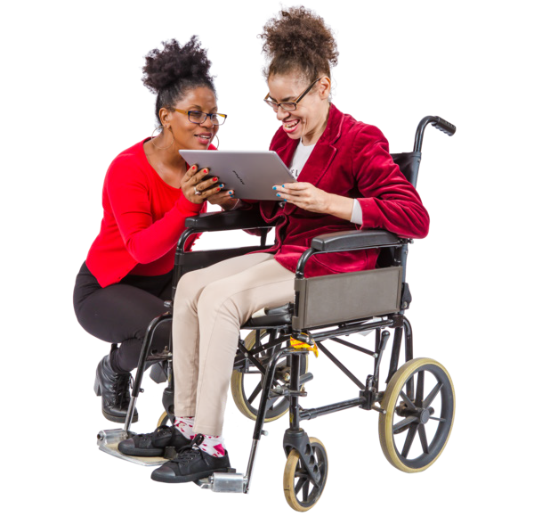The plan for our research will be about the lived experience of people with disability.

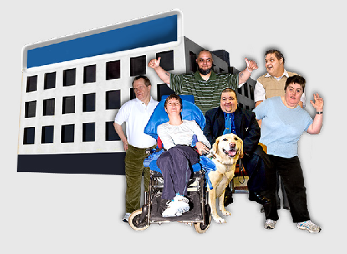
Our research is important to people with disability and their communities.

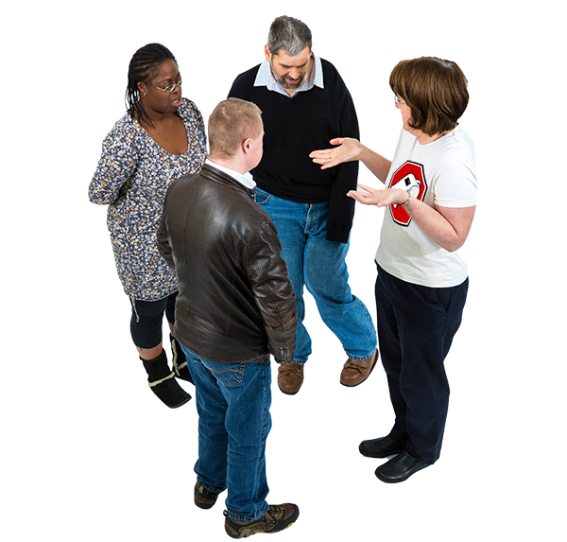We talk to the right people.

We make co-production better by learning from working together.

The next booklet

Booklet 3 will talk about the next step of co-research.

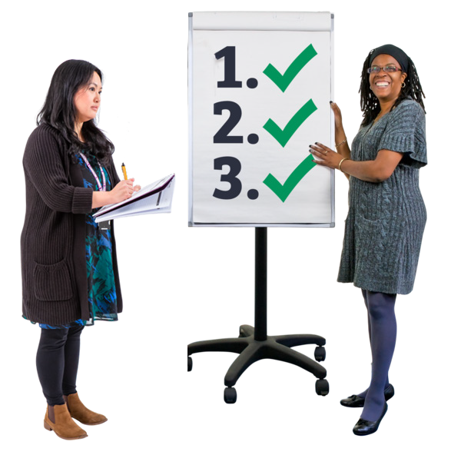The next step is called

Doing research together.

This guide was made by the Disability Innovation Institute at UNSW.
Council for Intellectual Disability made this document Easy Read. CID for short. You need to ask CID if you want to use any pictures in this document.
You can contact CID at business@cid.org.au 18

For more information contact:
Phone: 02 9385 9114
Email: diiu@unsw.edu.au
Website: www.disabilityinnovation.unsw.edu.au

