

Doing Research Inclusively. Co-production in Action.

Booklet 3

Doing research together

www.unsw.edu.au
1

Contents

About these booklets 1
Booklet 3 Doing research together 4
Fieldwork 5
Co-production in fieldwork 6
Making fieldwork safe 7
Things we can do together when we do fieldwork 9
Working together makes our fieldwork better 10
The next booklet 11

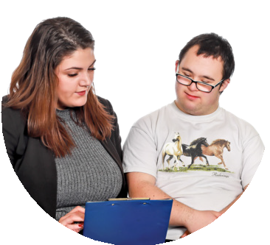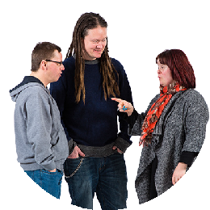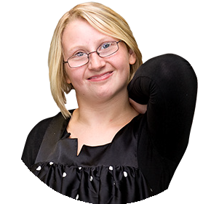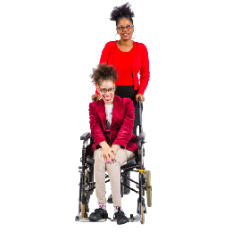About these booklets

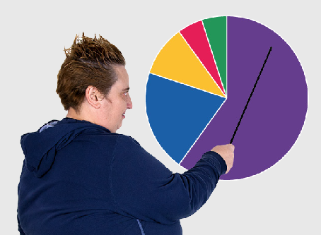
These booklets are a summary of Doing Research Inclusively: Co-production in Action.

Research is when we gather information to learn more about a topic.

Researchers at universities can work together with lots of different people

- People with disability

- Disability organisations and service providers

- Support workers

- Family and friends

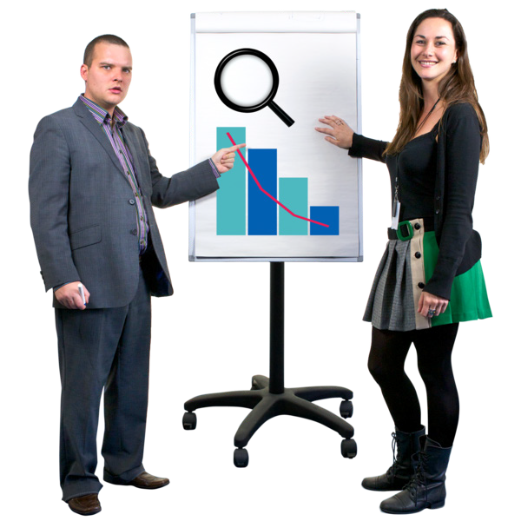We call these people co-researchers.

Co-researchers are people involved in the research who are not academic researchers.

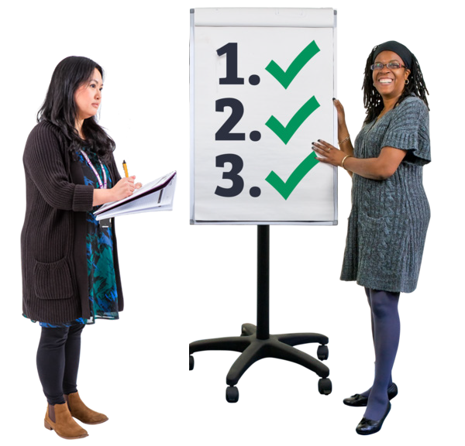Co-production means doing research together.

People with disability are included in the research process.

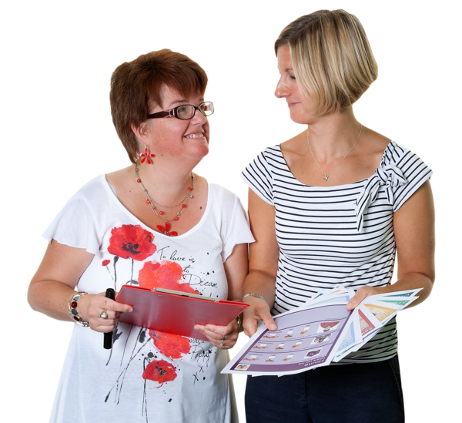This booklet talks about how we work together to do research.

There are 6 different booklets

1

2

3

4

5

6

- Starting research together

- Planning research together

Doing research together

- Understanding data together

- Sharing what we learnt together

- Talking about our research together

If you want to know more about co-production you can look at another booklet we made.

It is called Inclusive Research. A guide to doing research with people with disability.

Booklet 3 Doing research together

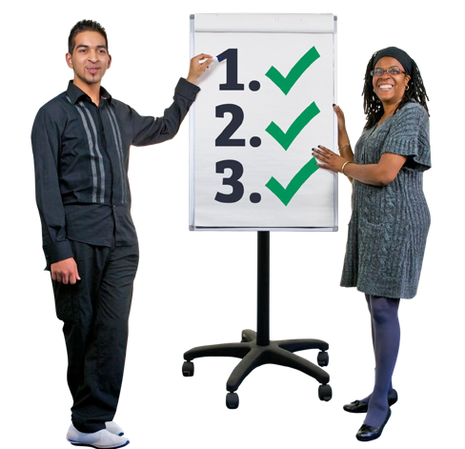This step is called

Doing research together.

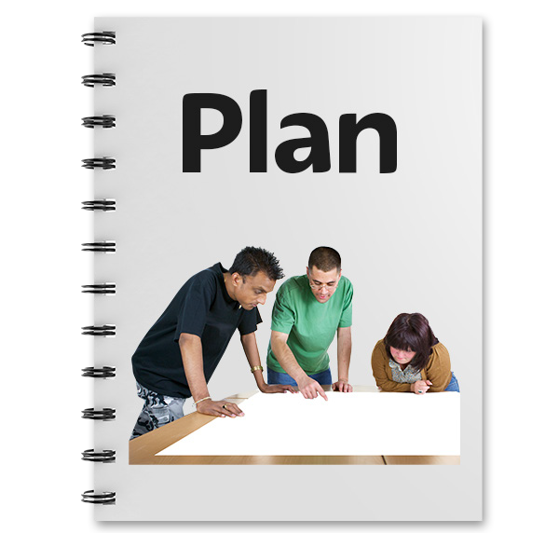In this step we start to do the things that are in our research plan.

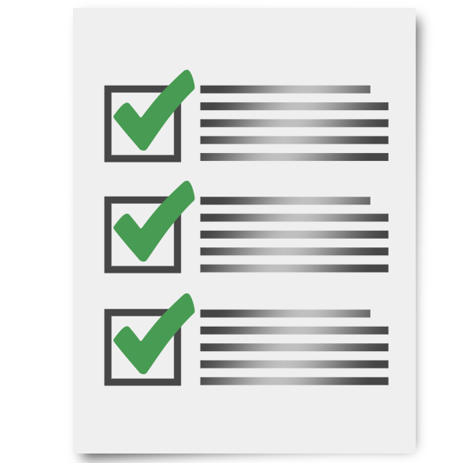We look at

- Our ethics

- Finding the right people to talk to

- Asking those people our questions

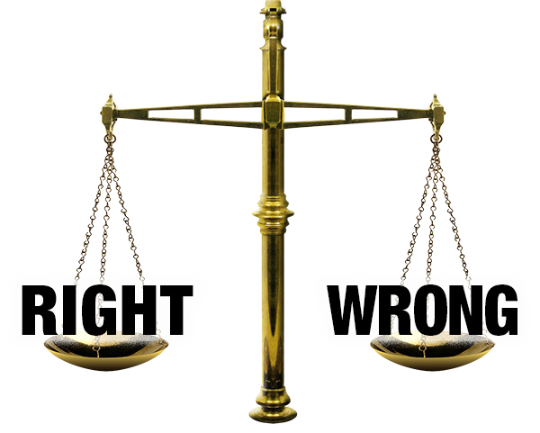Ethics

Ethics means making sure that research

- Is fair

- Does not harm anyone

Universities have an ethics committee

- They look at our plan to check whether it is okay

- We might need to make some changes

Fieldwork

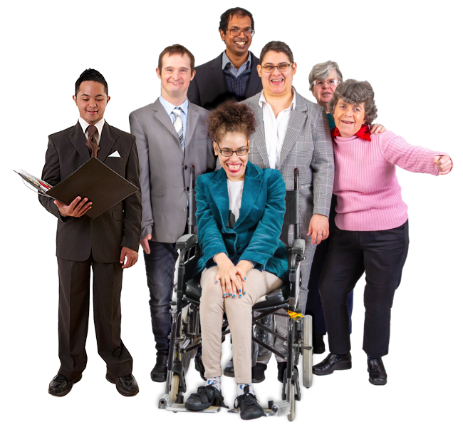In this step we go out into the community and collect information.

This is called fieldwork.

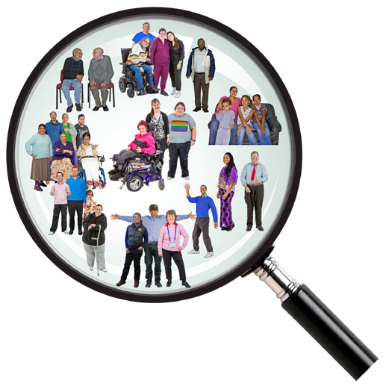This is when we can get in touch with disability groups to find people with disability who want to be in our research.

This is called recruitment.

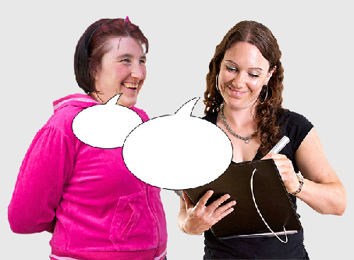
Researchers and co-researchers can be involved in collecting data.

Data is the information that people tell us.

Data can be collected in different ways. For example
- Interviews

- Surveys
- Watching people do an activity 5

Co-production in fieldwork
Having people with lived experience of disability doing fieldwork is important.
This is co-production in fieldwork.

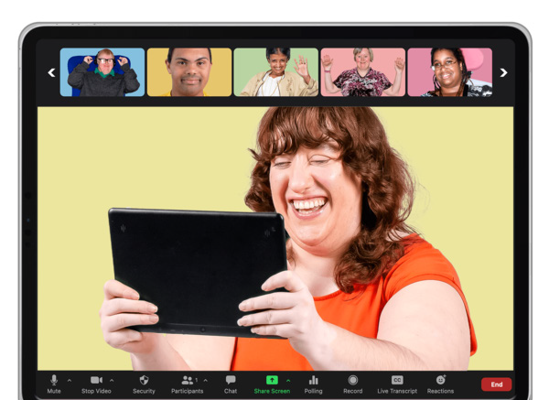Co-production makes sure we get data in a way that is safe and accessible for everyone.

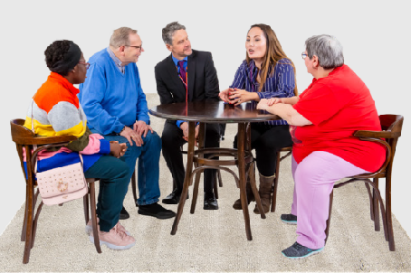
The co-researchers suggest the best way to work with people.

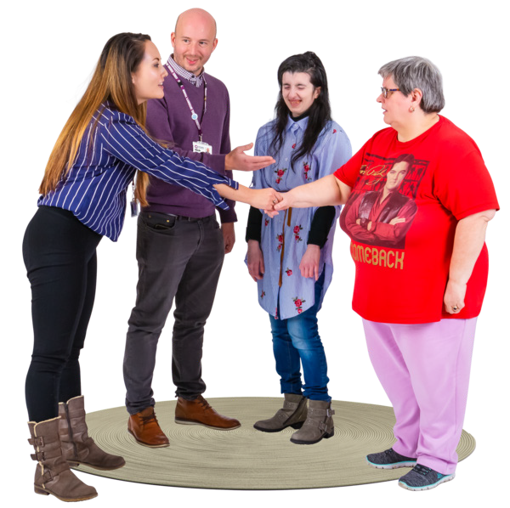People in our research might feel better talking to someone with the same experience as them.

Working together when we do fieldwork shows we respect the people we talk to.

Making fieldwork safe

Co-researchers might hear things that really upset them.

Hearing these things might bring up bad feelings about something that has happened to them before.

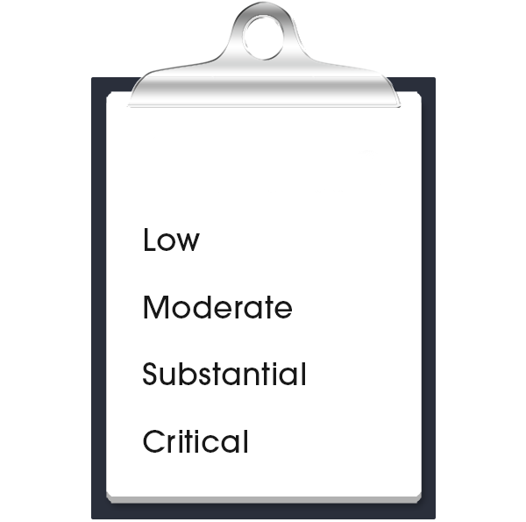The team should do a risk assessment.

risk assessment

A risk assessment is a plan to keep everyone safe.

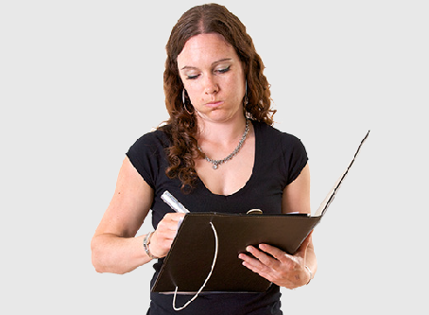
In the risk assessment we

- Make a list of things that we think could go wrong
- Plan how we will stop these things from happening
- Decide what we will do if something goes wrong

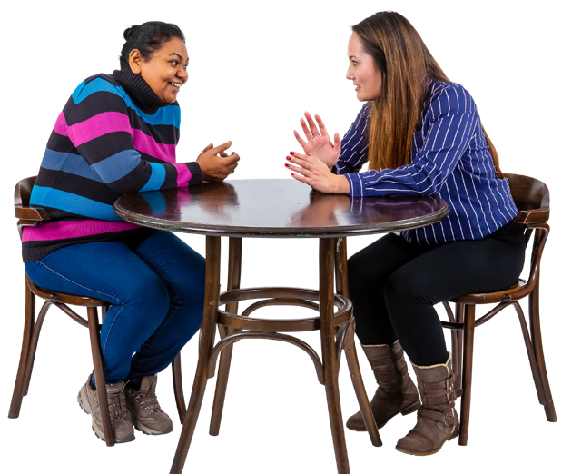The researcher or co-researcher might know the person they are talking to.

This is a risk we need to think about.

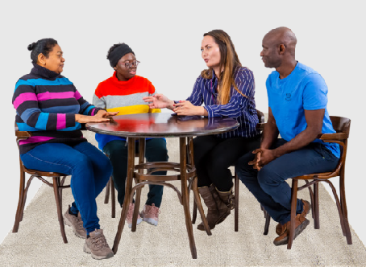
If we know the person it could affect

- The way we get the information

- Our friendship or relationship with them

- Their privacy - we might find out new information about them

Things we can do together when we do fieldwork

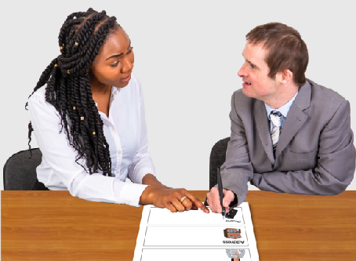
Help the ethics committee to learn about co-production with people with disability.

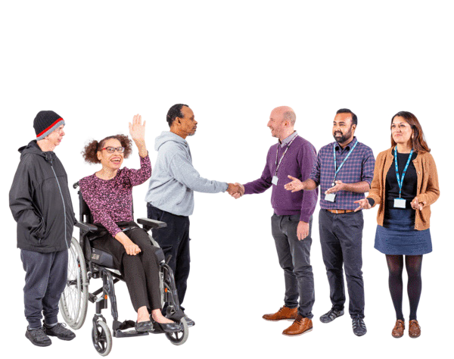Find the right people and talk to them in a safe and respectful way.

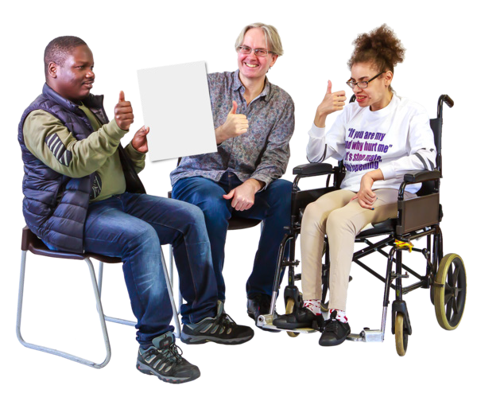Make sure we get the information in a way that is right and clear for the

- Project

- Research team

- People we talk to

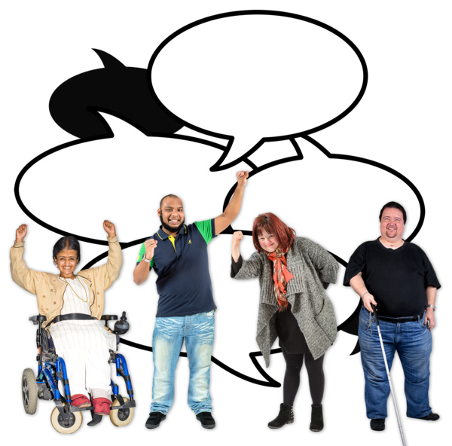Think about what we learnt about doing fieldwork together and tell other people about it, so they can learn.

Working together makes our fieldwork better

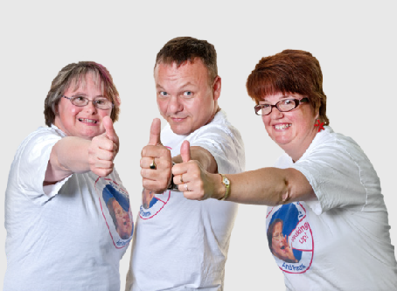
Our research is fairer and safer.

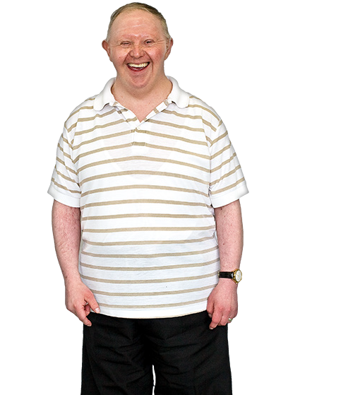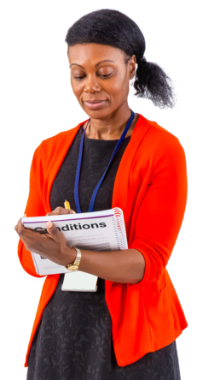The way we talk to people is safe and respectful.

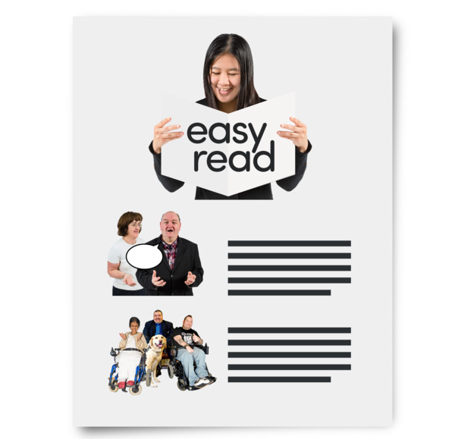The way we do our fieldwork is accessible.

The next booklet

Booklet 4 will talk about making sense of what people told us.

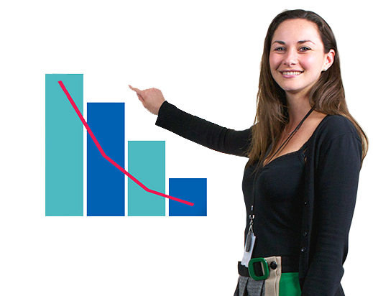The next step is called

Understanding data together.

This guide was made by the Disability Innovation Institute at UNSW.
Council for Intellectual Disability made this document Easy Read. CID for short. You need to ask CID if you want to use any pictures in this document.
You can contact CID at business@cid.org.au 11

For more information contact:
12

Phone: 02 9385 9114

Email: diiu@unsw.edu.au

Website: www.disabilityinnovation.unsw.edu.au

