Doing Research Inclusively. Co-production in Action.

Booklet 4

Understanding data together

www.unsw.edu.au
1

Contents

About these booklets 1
Booklet 4 Understanding data together 4
Is the way we do data analysis accessible? 6
How do we support each other in our research? 8
The next booklet 9

About these booklets

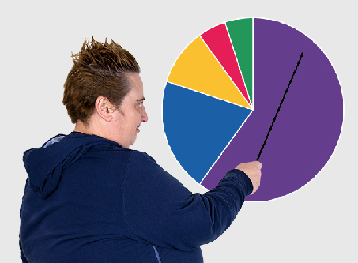
These booklets are a summary of Doing Research Inclusively: Co-production in Action.

Research is when we gather information to learn more about a topic.

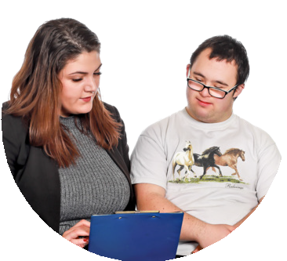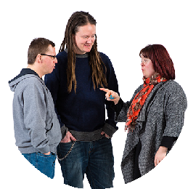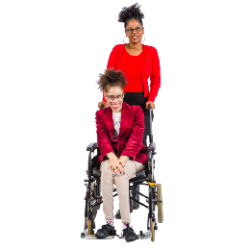Researchers at universities can work together with lots of different people

- People with disability

- Disability organisations and service providers

- Support workers

- Family and friends

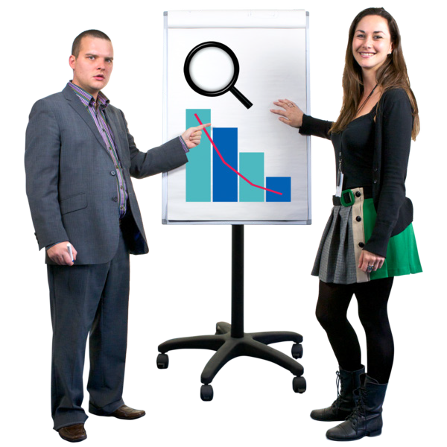We call these people co-researchers.

Co-researchers are people involved in the research who are not academic researchers.

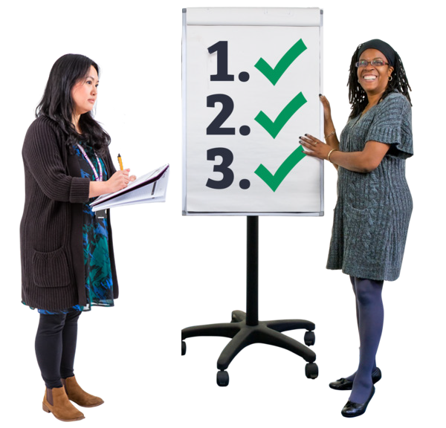Co-production means doing research together.

People with disability are included in the research process.

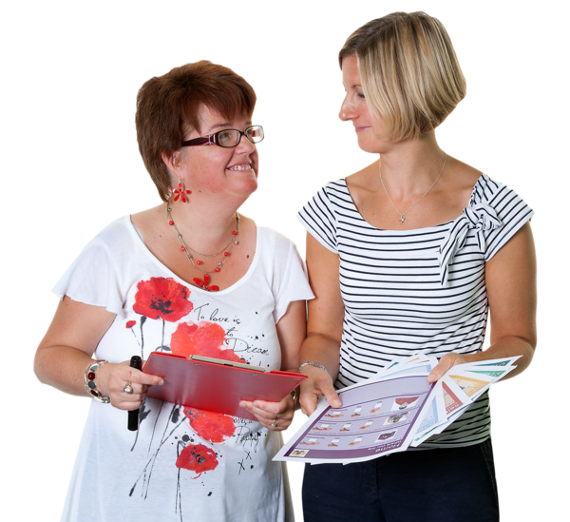This booklet talks about how we work together to do research.

There are 6 different booklets

1

2

3

4

5

6

- Starting research together

- Planning research together

- Doing research together

Understanding data together

- Sharing what we learnt together

- Talking about our research together

If you want to know more about co-production you can look at another booklet we made.

It is called Inclusive Research. A guide to doing research with people with disability.

Booklet 4 Understanding data together

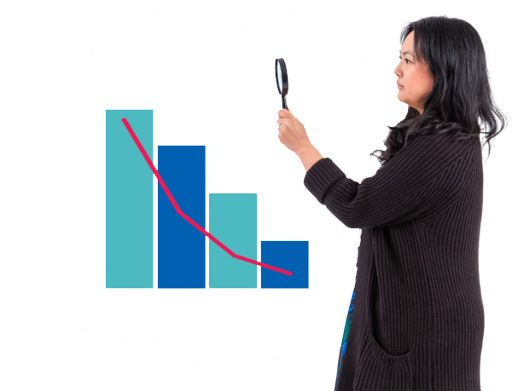This step is called

Understanding data together.

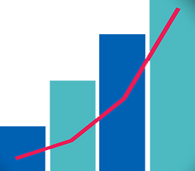Data is all the information we find out in our fieldwork.

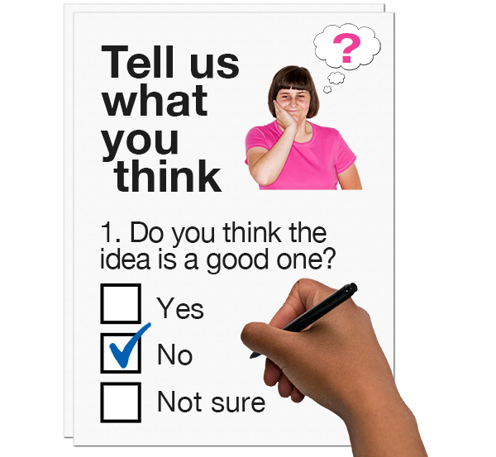Data can be things like

- Survey answers

- What people said in interviews

In this step we try to make sense of the data we collected in fieldwork.

We call this data analysis.

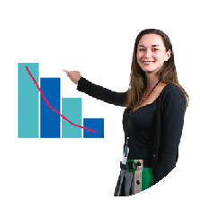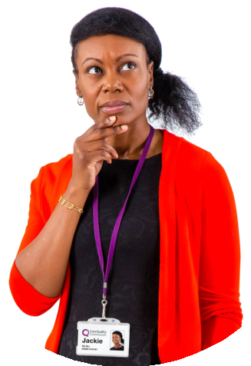In this step we

- Look at what we found out

- Think about what it means

- See if we have answers to our research questions

- Look at what needs to change for people with disability

Is the way we do data analysis accessible?

In this step we make sure we do things in a way that everyone can understand.

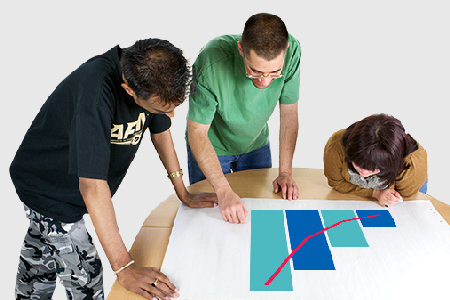
As a team we decide the best way to look at the data we collected together.

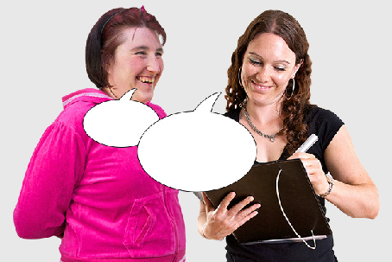
Researchers and co-researchers talk about what they think the data tells us about the research questions.

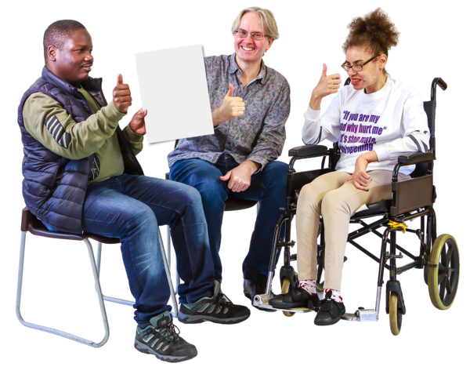Researchers and co-researchers always talk about the data collected in a way that is respectful of people with disability.

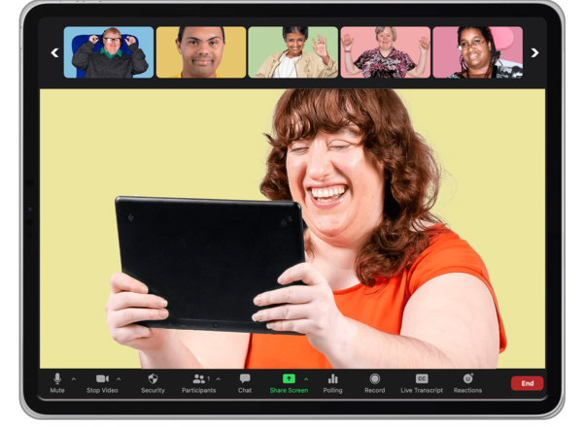This is so that we can make sure that a lot of different people can access the information.

We can make sure everyone learns something from doing this step.

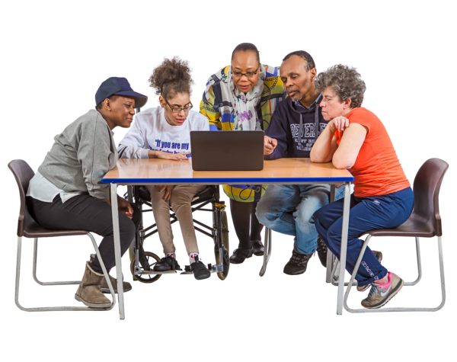When we make sense of the data we need to think about different ways that we can show the information.

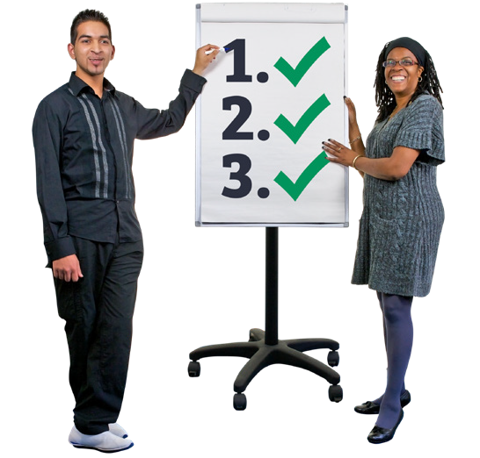We can be creative in how we show our information.

We could

- Make reports short

- Use visual formats

- Have focus groups

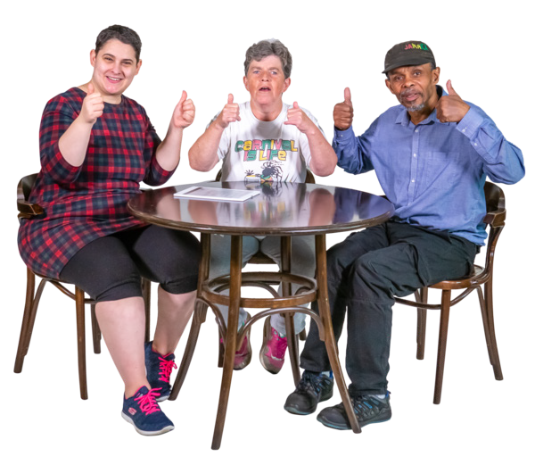We must always think about how to share our research in ways that everyone can understand.

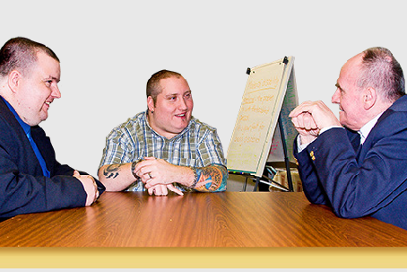
How do we support each other in our research?

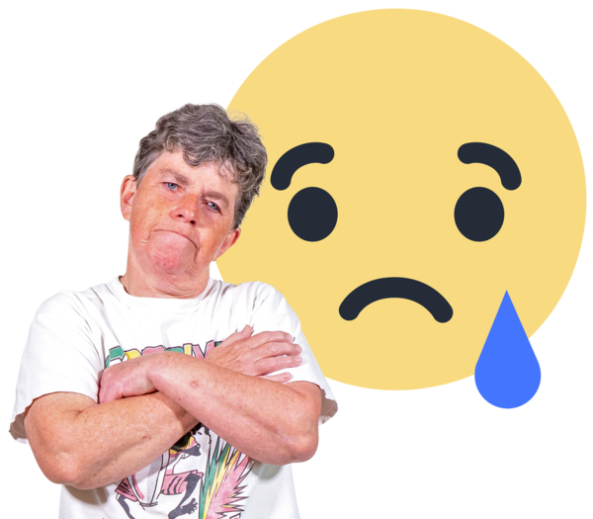Co-researchers can have lived experience of the research topic.

This means that sometimes the data collected can be make them upset.

As a team we will make a plan to help keep everyone safe and supported.

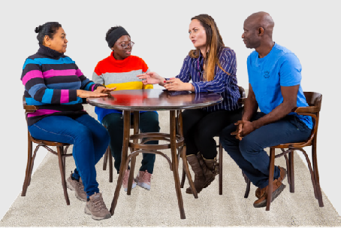
Having a plan can help the team to make the right choice about how involved
co-researchers are in data analysis.

In co-production everyone wants to make life better for people with disability.

Looking closely at the data collected helps everyone to learn why things need to change.

The next booklet

Booklet 5 will talk about how to share what we have found out from doing the research.

The next step is called

Sharing what we learnt together.

This guide was made by the Disability Innovation Institute at UNSW.
Council for Intellectual Disability made this document Easy Read. CID for short. You need to ask CID if you want to use any pictures in this document.
You can contact CID at business@cid.org.au 9

For more information contact:
10

Phone: 02 9385 9114

Email: diiu@unsw.edu.au

Website: www.disabilityinnovation.unsw.edu.au

