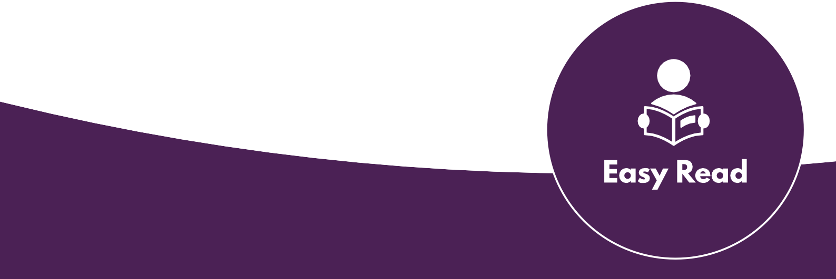

Doing Research Inclusively. Co-production in Action.

Booklet 5

Sharing what we learnt together

www.unsw.edu.au
1

Contents

About these booklets 1
Booklet 5 Sharing what we learnt together 4
Who needs to know what we found out? 6
Sharing our research findings with different audiences 8
How we can share our research together 10
Why co-production improves the research 11
The next booklet 12

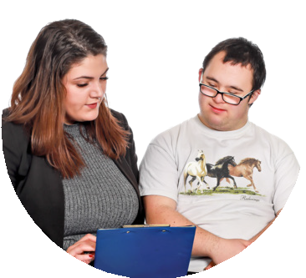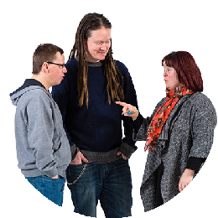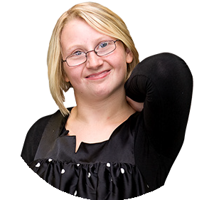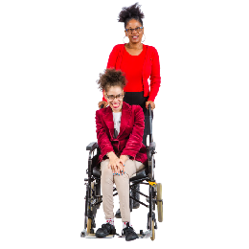About these booklets

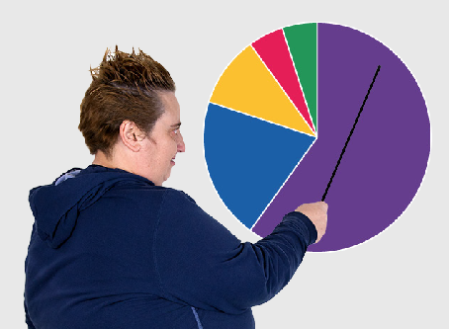
These booklets are a summary of Doing Research Inclusively: Co-production in Action.

Research is when we gather information to learn more about a topic.

Researchers at universities can work together with lots of different people

- People with disability

- Disability organisations and service providers

- Support workers

- Family and friends

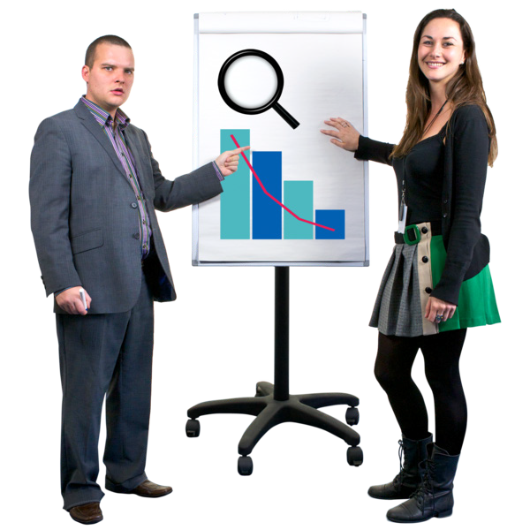We call these people co-researchers.

Co-researchers are people involved in the research who are not academic researchers.

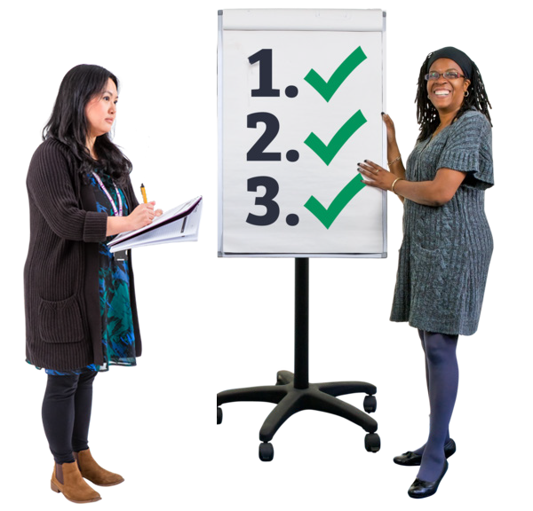Co-production means doing research together.

People with disability are included in the research process.

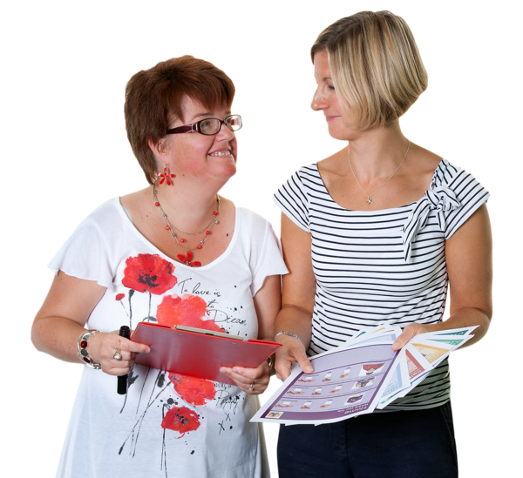This booklet talks about how we work together to do research.

There are 6 different booklets

1

2

3

4

5

6

- Starting research together

- Planning research together

- Doing research together

- Understanding data together

Sharing what we learnt together

- Talking about our research together

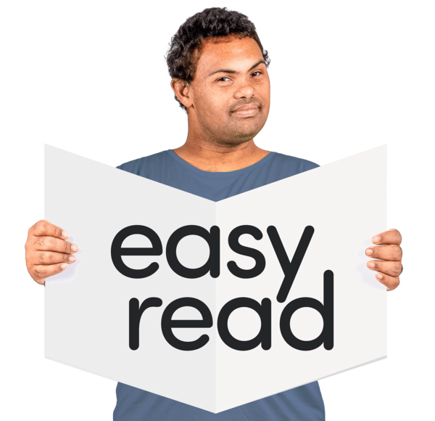If you want to know more about co-production you can look at another booklet we made.

It is called Inclusive Research. A guide to doing research with people with disability.

Booklet 5 Sharing what we learnt together

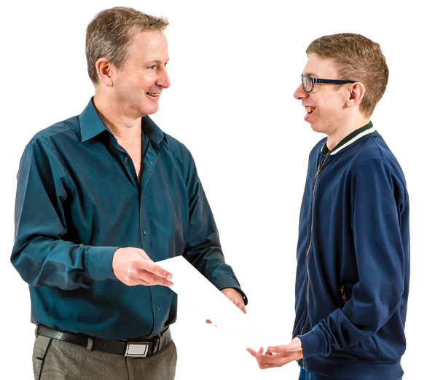This step is called

Sharing what we learnt together.

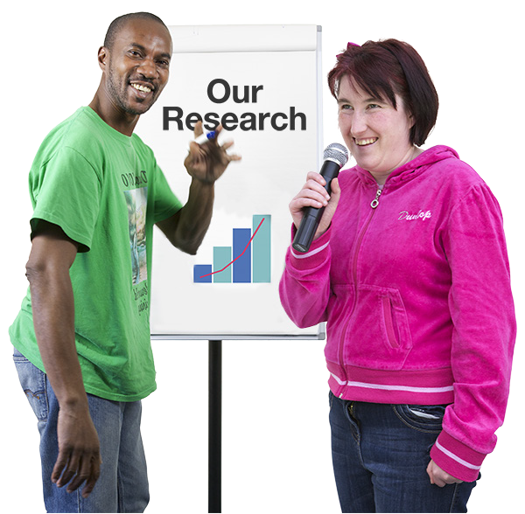In this step we discuss how to share what we have found out from doing the research.

In this step we work together to choose who we share what we found out with.

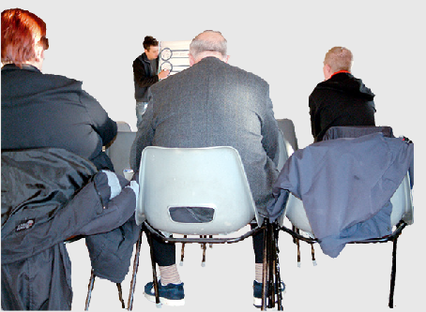
We will share what we have found with a lot of people in the community.

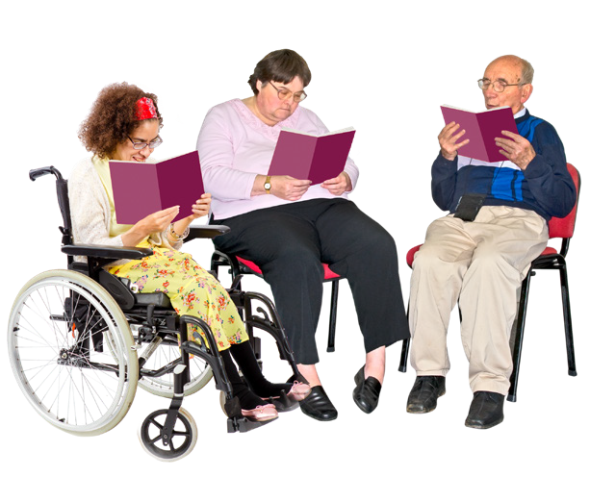Together we will work out how we share what we found out in a way that everyone understands.

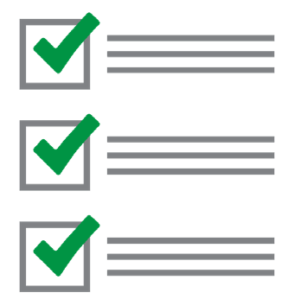There is a to do list to help in this step.

You can find the to do list in the booklet called Documents to help us do research together.

The list is called Sharing plan for co-produced research.

Who needs to know what we found out?

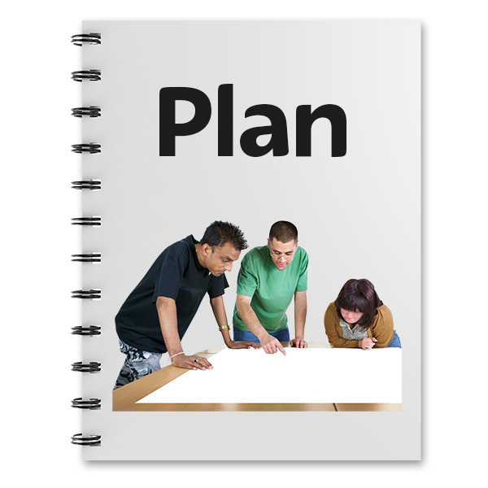We need to plan how we share what we have found out.

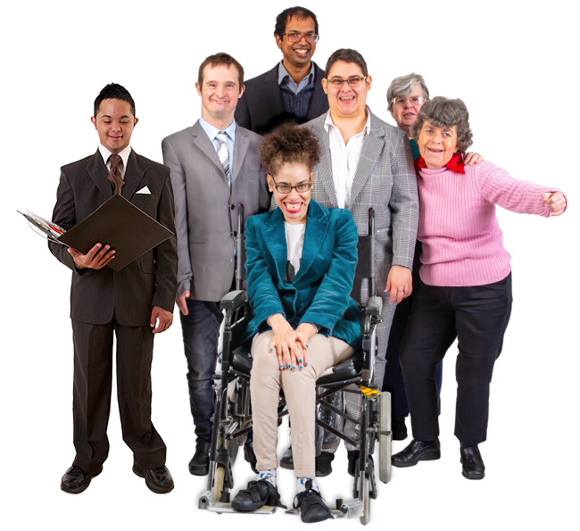Lots of people with different needs will be looking at what we share.

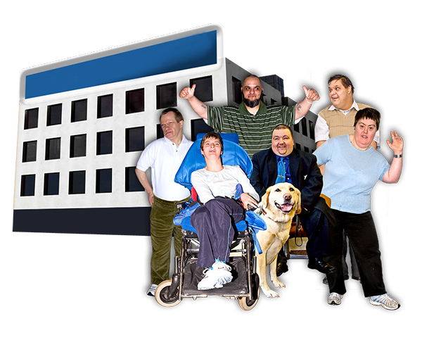We will work together as a team to find out the best way to contact

- Disability organisations

- Other people who would like to see the info

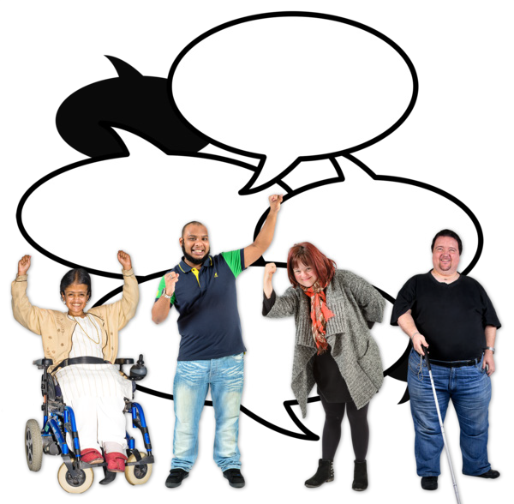Co-researchers with disability on the team can share the research with lots of places that they know.

This could be

- Service providers

- Other organisations

- Other people with disability

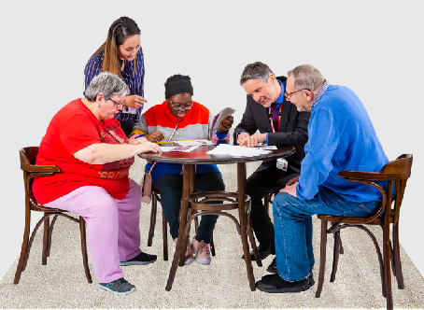
Everyone on the team can work on letting people know about how we did co-production.

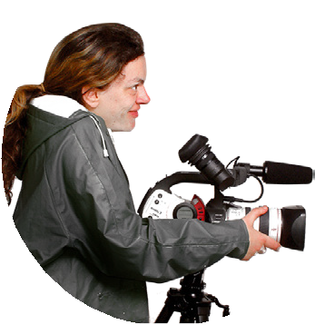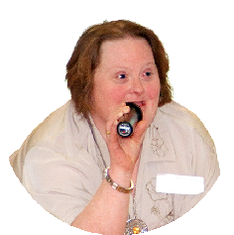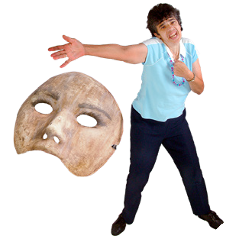Sharing our research findings with different audiences

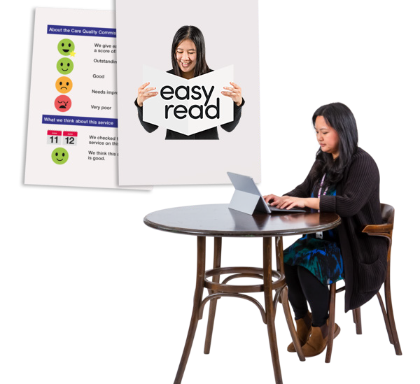We can share what we found out in lots of different ways.

This makes our work more accessible.

We can

- Write journal articles

- Speak at conferences

- Make videos and podcasts

- Make a theatre show

- Write an Easy Read report about our research

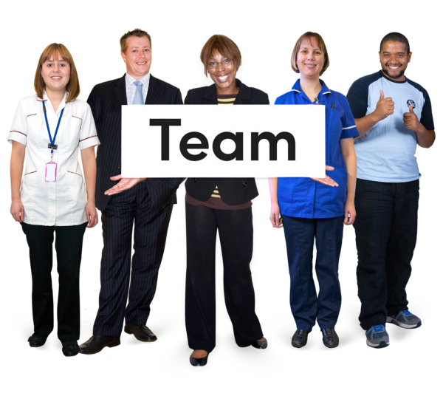As a team we need to think about who is going to be the audience for each of these things.

Audience means the people who will read or watch the things we present.

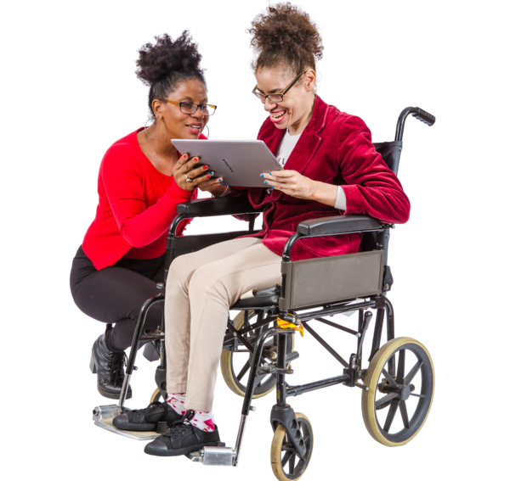When we know the audience we can make sure it is accessible for them.

For example

- A journal article might be more for university researchers because it has harder words

- An Easy Read article could be used for anyone in the community

- A theatre show could be very accessible and be for anyone in the community

How we can share our research together

We will make sure what we find out gets put into Easy Read.

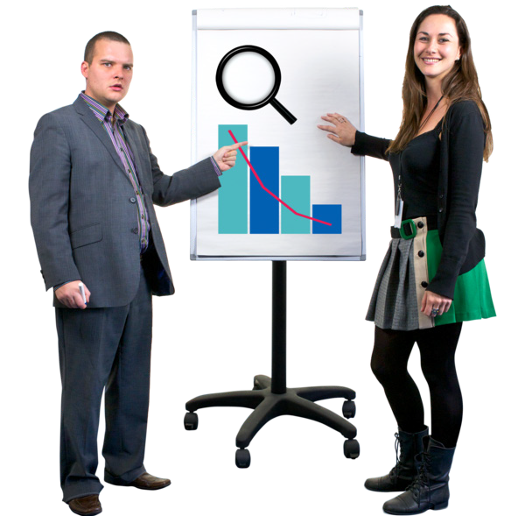We will present our research findings together at events.

We will write journal articles together.

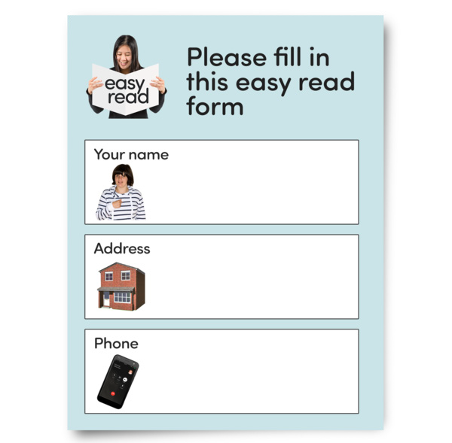This will make sure that the research is accessible.

Why co-production improves the research

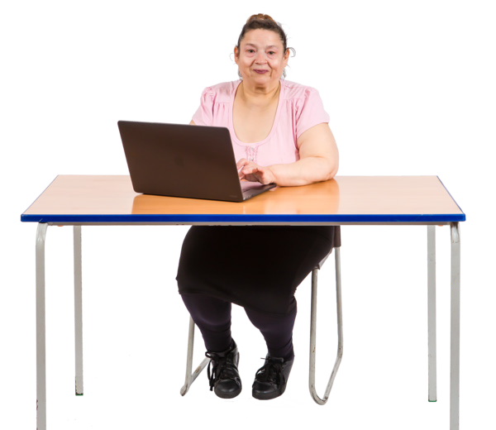A lot of people will be able to access the info that we share about our study.

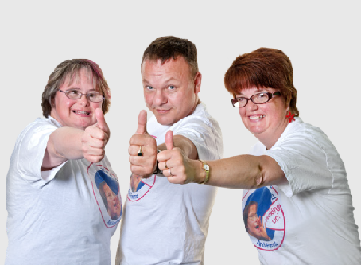
It will show others that doing good research means working together with people
with disability.

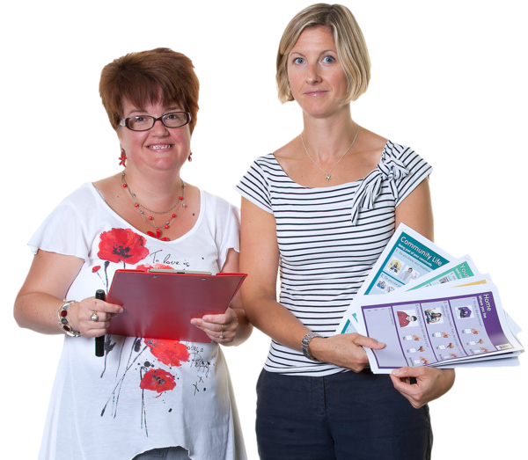When people with disability see what we share they will be able to connect it to their own life.

The next booklet

In the next booklet we will talk about the research that we have done.

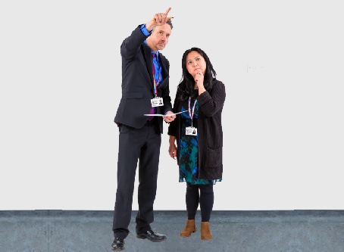
The next step is called

Talking about our research together.

This guide was made by the Disability Innovation Institute at UNSW.
Council for Intellectual Disability made this document Easy Read. CID for short. You need to ask CID if you want to use any pictures in this document.
You can contact CID at business@cid.org.au 12

For more information contact:
13

Phone: 02 9385 9114

Email: diiu@unsw.edu.au

Website: www.disabilityinnovation.unsw.edu.au

