Doing Research Inclusively. Co-production in Action.

Booklet 6

Talking about our research together

www.unsw.edu.au
1

Contents

About these booklets 1
Booklet 6 Talking about our research together 4
Talking about our experience of co-production 5
How did co-production make the research better? 6
Good things about co-production 8

About these booklets

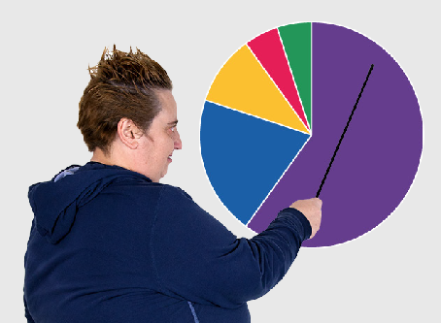
These booklets are a summary of Doing Research Inclusively: Co-production in Action.

Research is when we gather information to learn more about a topic.

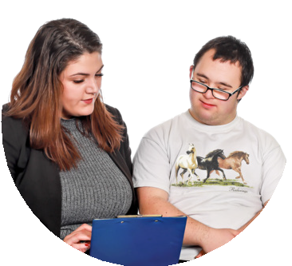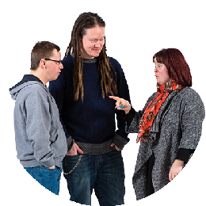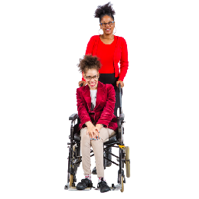Researchers at universities can work together with lots of different people

- People with disability

- Disability organisations and service providers

- Support workers

- Family and friends

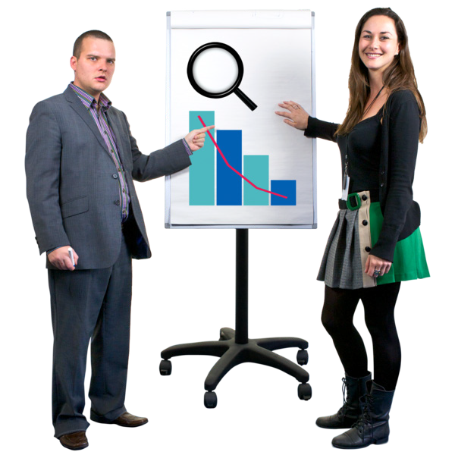We call these people co-researchers.

Co-researchers are people involved in the research who are not academic researchers.

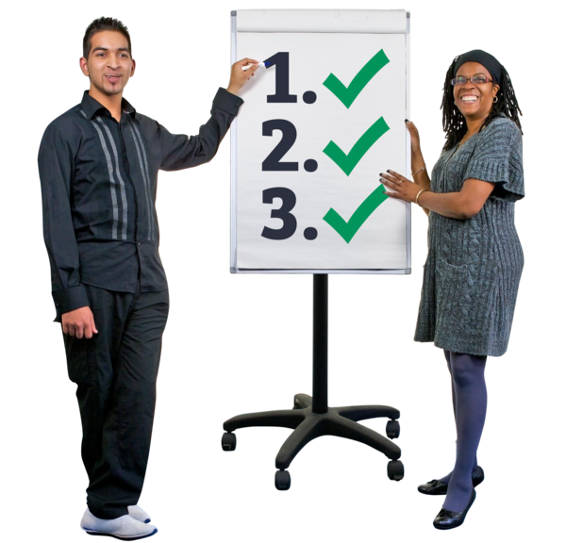Co-production means doing research together.

People with disability are included in the research process.

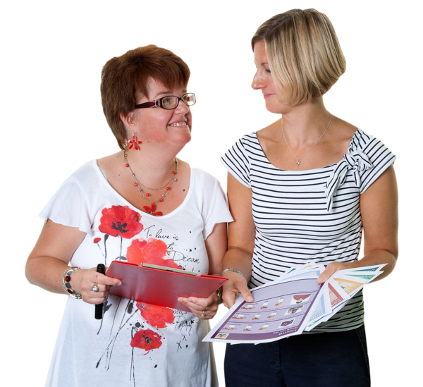This booklet talks about how we work together to do research.

There are 6 different booklets

1

2

3

4

5

6

- Starting research together

- Planning research together

- Doing research together

- Understanding data together

- Sharing what we learnt together

Talking about our research together

If you want to know more about co-production you can look at another booklet we made.

It is called Inclusive Research. A guide to doing research with people with disability.

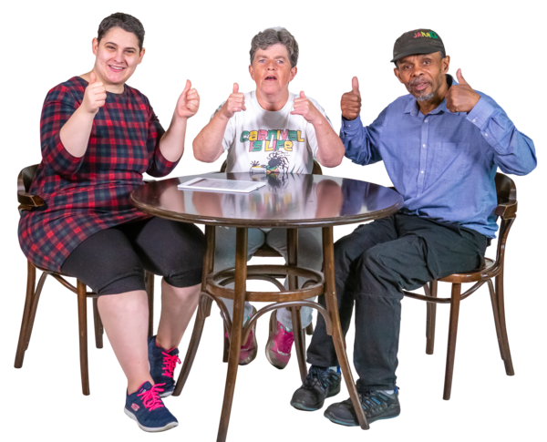Booklet 6 Talking about our research together

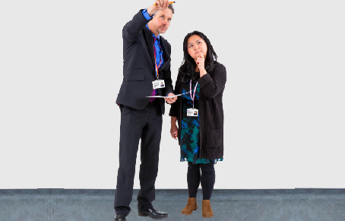
This step is called

Talking about our research together.

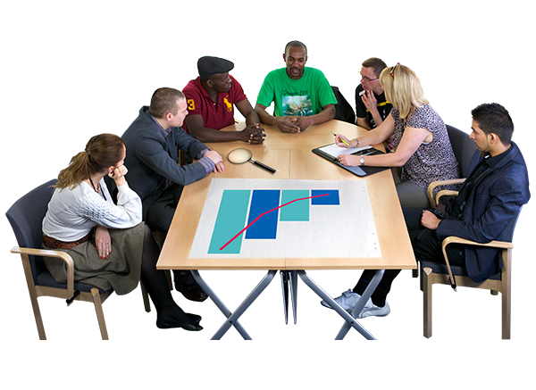In this step we think about the research we have done together.

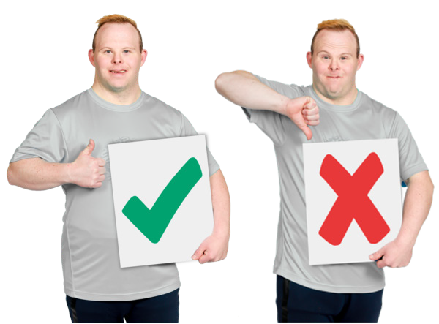We talk about what worked and what did not work.

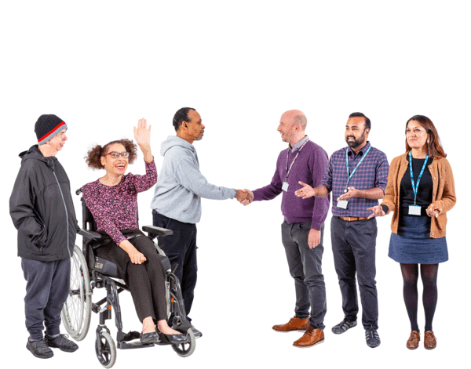We can be open and honest about what we think and feel about what we did.

This will help us learn and grow.

What we have learnt can help other teams do co-production.

Talking about our experience of co-production

In this step we talk about what went well in the research project.

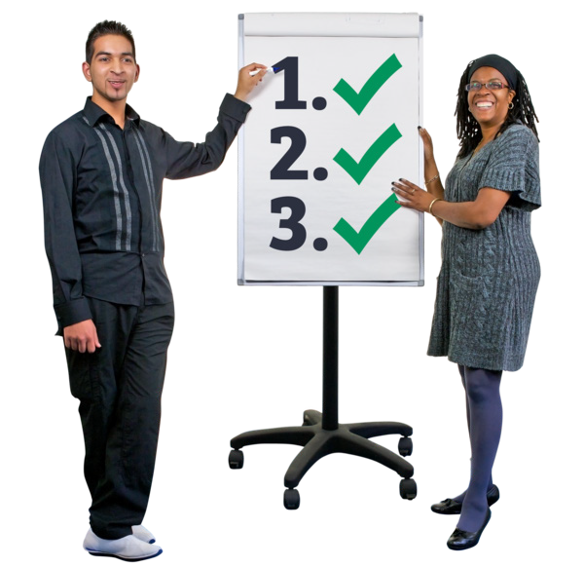It is also important to look at what we could have done better in all of the steps.

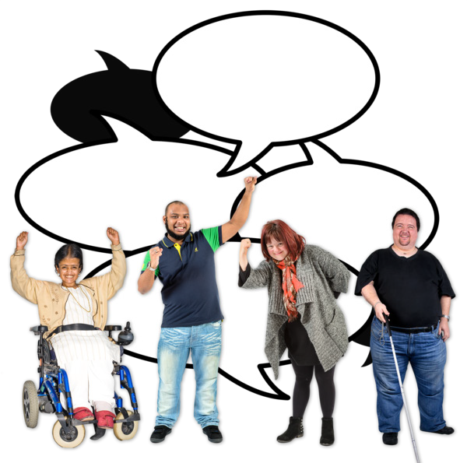It is important to be honest and for everyone to have their say.

How did co-production make the research better?

We can think about how co-production made the project better.

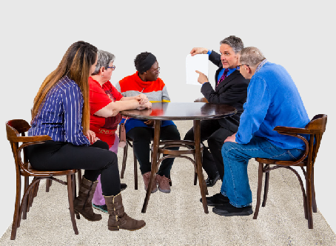
We need to think about how co-production helped with

- The project plan

- What we did

- What we found out

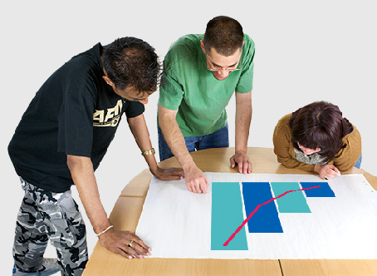
Co-production in this step happens when we look at what we have done together.

We can share when things went well and when they did not.

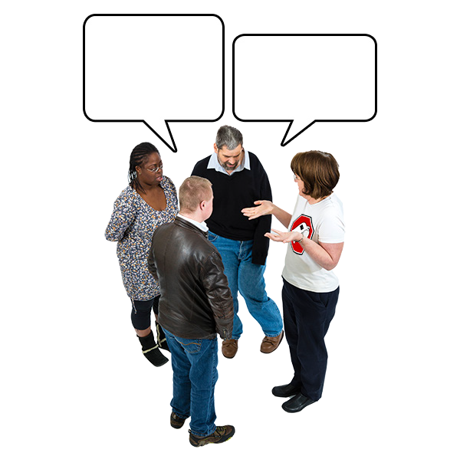When we are working together we can talk about how it is going.

This will help us learn as we do things.

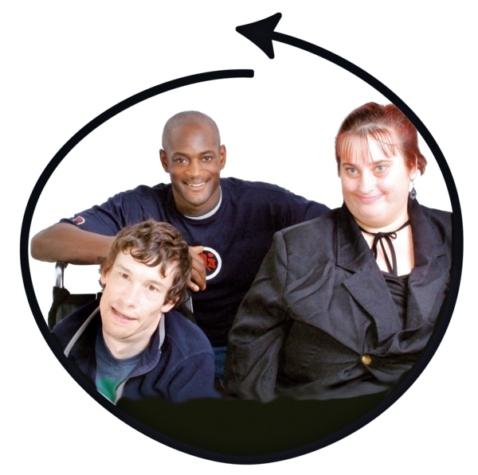We can talk about what inclusion felt like when we were working together.

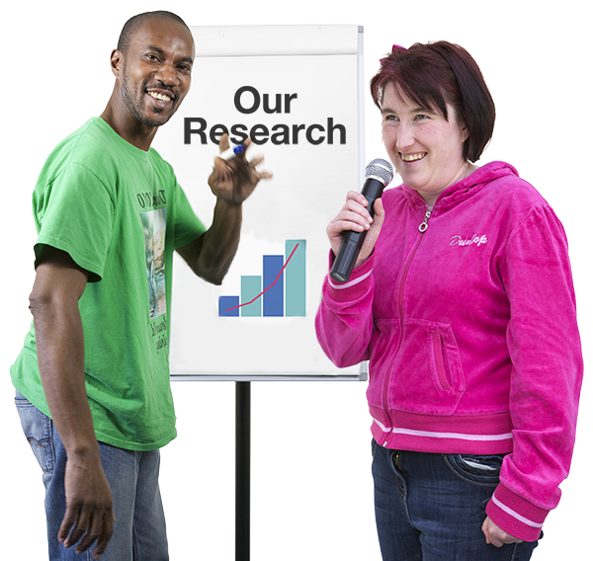Good things about co-production

These are the things we will be able to do in this step.

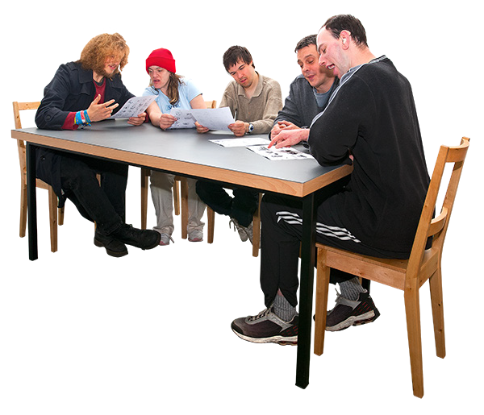Both researchers and co-researchers can learn new skills.

It can help to make sure we work together for a long time.

This will help with good research.

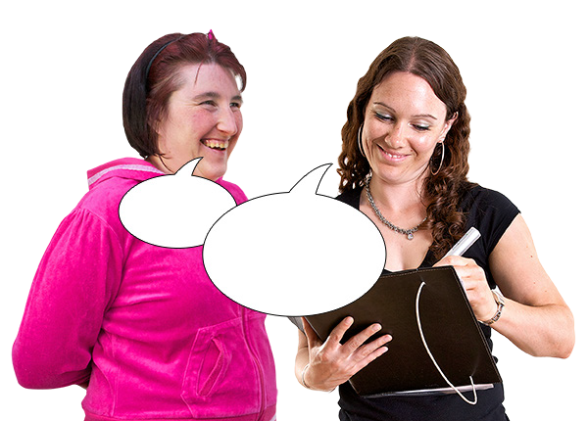Researchers will understand different disabilities and support needs better.

Doing co-production makes research with people with disability better.

It is important to think about what is next for the team and the research.

The things that we learnt can help other teams do co-research.

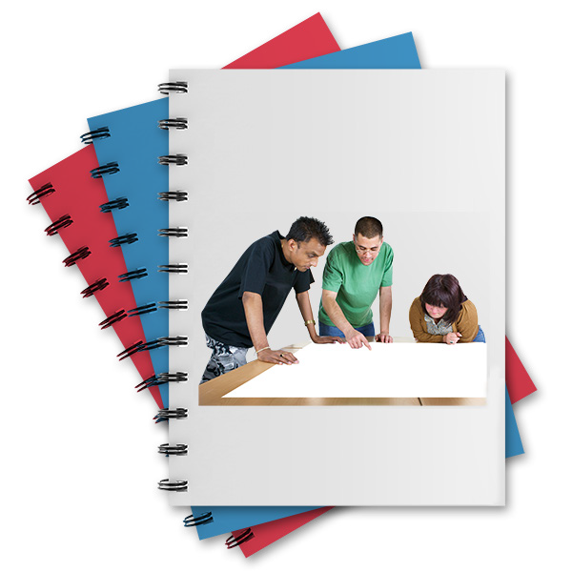This is the last step in the guide.
guide

We have one more booklet that has some to do lists to help with the steps.

The booklet is called

Documents to help us do research together.

This guide was made by the Disability Innovation Institute at UNSW.
Council for Intellectual Disability made this document Easy Read. CID for short. You need to ask CID if you want to use any pictures in this document.
You can contact CID at business@cid.org.au 9

For more information contact:
10

Phone: 02 9385 9114

Email: diiu@unsw.edu.au

Website: www.disabilityinnovation.unsw.edu.au

