Doing Research Inclusively. Co-production in Action.

Documents to help us do research together

www.unsw.edu.au
1

Contents

Co-production agreement 1

Sharing our skills and experience with the team 5

Sharing plan for co-produced research 8

Co-production agreement

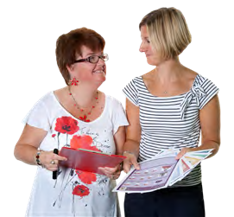This is the co-production agreement.

This is an agreement between you and the other members of the research team.

We will go through the agreement together.

There will be 2 tick boxes below each sentence.

We only need to tick the boxes that are right for us.

The 1st tick box says that we discussed the sentence.

The 2nd tick box says that we agreed to it.

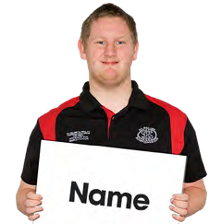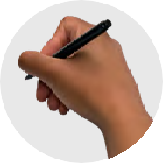Write the project name here

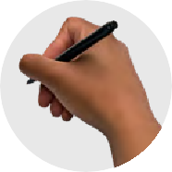Write what the research is about

Discussed Agreed

We talked about

- What you will do in the job

- The hours you will work

- What you get paid We agreed on it.
Discussed Agreed

We talked about how we make decisions. We agreed on how we make decisions.
Discussed Agreed

We talked about what we will do if

- There is a conflict of interest

- We have different opinions We agreed on it.
Discussed Agreed

We talked about who will do which jobs in the project.

We agreed on it.

Discussed Agreed

We talked about what support we need. We agreed on it.
Discussed Agreed

We talked about how we make sure everyone is safe.

We agreed on it.

Discussed Agreed

Sharing our skills and experience with the team

This form is a chance to share our skills and experience.

We will do it together.

We will write our answers in the boxes.

What skills do we each bring to the project?

What life experiences do we each bring to the project?

How much time do we each have to work on the project?

What jobs can we share?

Who do we know that could help with the research?

How can we support each other?

Sharing plan for co-produced research

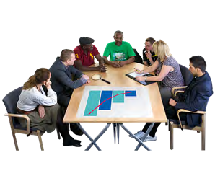This plan is about how we want to share our research.

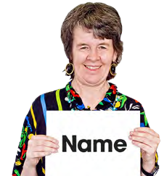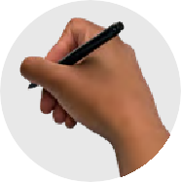Write the project name here

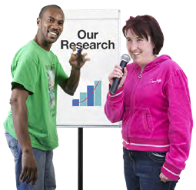What our research is about

Researchers and co-researchers can complete this form together.

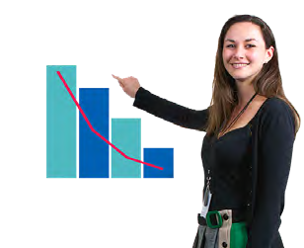Why do we want to share our research?

Who do we want to share our research with?

What are the most important things we want to share?

How will we share what we want to say?

When will we share our research?

What things do we need to help us share our research?

This guide was made by the Disability Innovation Institute at UNSW.
Council for Intellectual Disability made this document Easy Read. CID for short. You need to ask CID if you want to use any pictures in this document.
You can contact CID at business@cid.org.au 11

For more information contact:
12
Phone: 02 9385 9114
Email: diiu@unsw.edu.au
Website: www.disabilityinnovation.unsw.edu.au

