Doing Research Inclusively. Co-production in Action.

Summary of the Booklets

www.unsw.edu.au
1

Contents

About these booklets 1

Booklet 1 Starting research together 4

Booklet 2 Planning research together 6

Booklet 3 Doing research together 8

Booklet 4 Understanding data together 10

Booklet 5 Sharing what we learnt together 12

Booklet 6 Talking about our research together 13

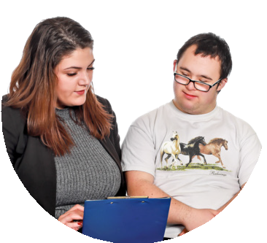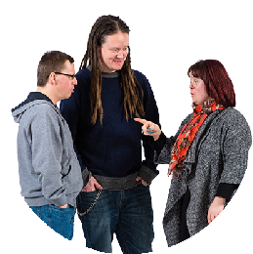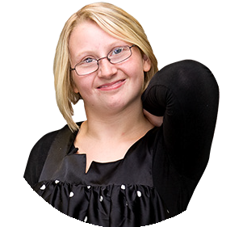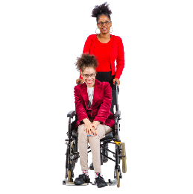About these booklets

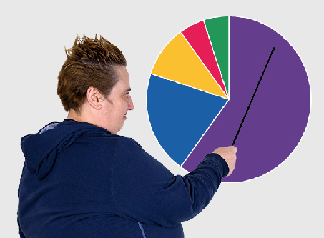
These booklets are a summary of Doing Research Inclusively: Co-production in Action.

Research is when we gather information to learn more about a topic.

Researchers at universities can work together with lots of different people

- People with disability

- Disability organisations and service providers

- Support workers

- Family and friends

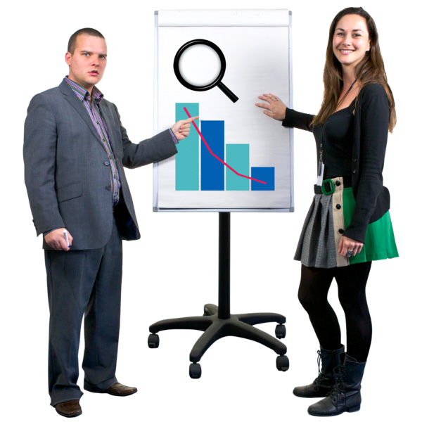We call these people co-researchers.

Co-researchers are people involved in the research who are not academic researchers.

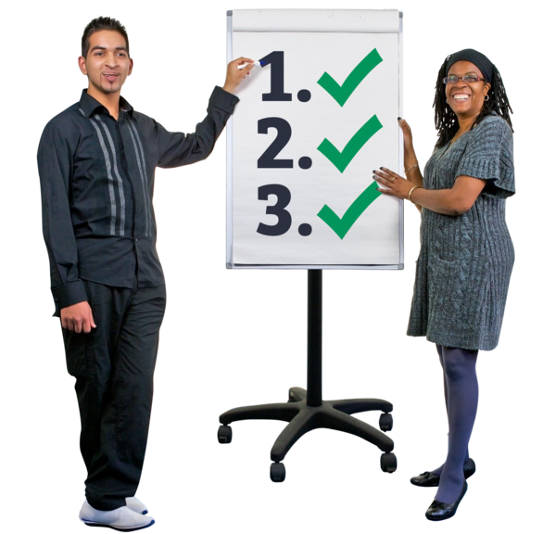Co-production means doing research together.

People with disability are included in the research process.

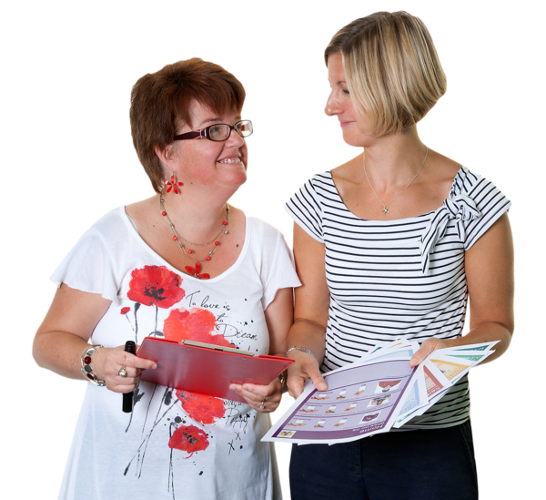This Summary of the Booklets talks about how we work together to do research.

There are 6 different booklets

1

2

3

4

5

6

- Starting research together

- Planning research together

- Doing research together

- Understanding data together

- Sharing what we learnt together

- Talking about our research together

If you want to know more about co-production you can look at another booklet we made.

It is called Inclusive Research. A guide to doing research with people with disability.

Booklet 1 Starting research together

Booklet 1 is called

Starting research together.

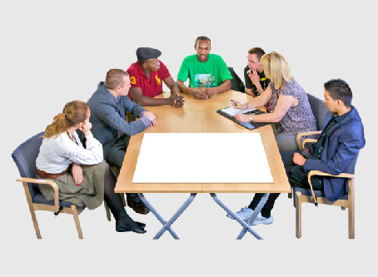
In this step we get to know everyone in the team.

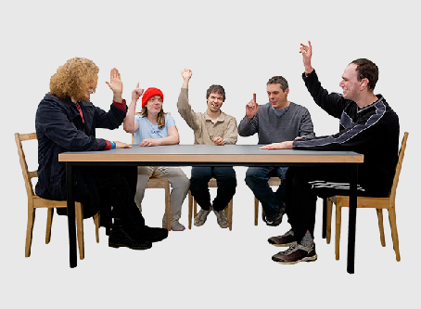
We choose what jobs everyone will do.

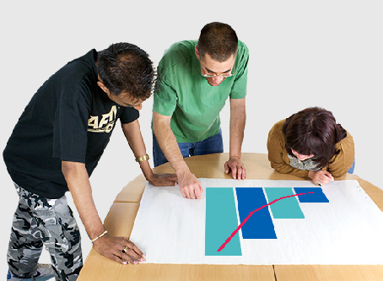
We think a lot about

- What our research will be about

- How we want to do things

We make sure our research is important for people with disability.

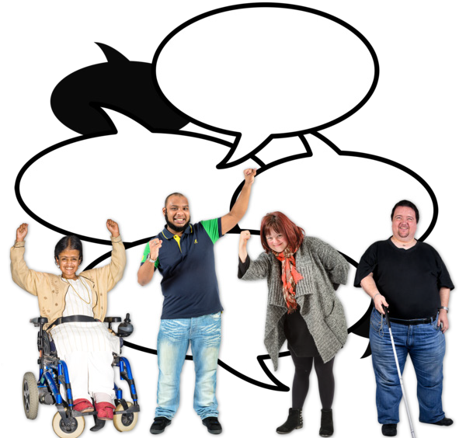We ask people with disability what they think.

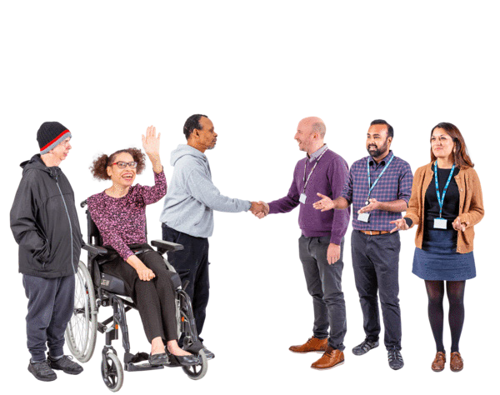We ask other groups like disability organisations what they think.

We think about how everything we do can be accessible.

Accessible means that everyone can understand it.

Booklet 2 Planning research together

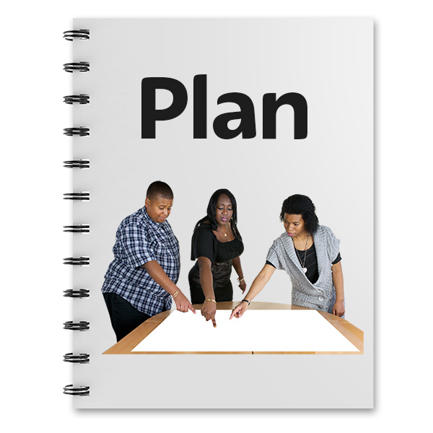Booklet 2 is called

Planning research together.

In this step we plan a lot of things for our research.

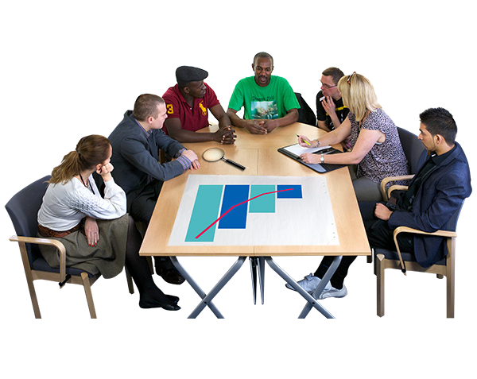We plan what we will research.

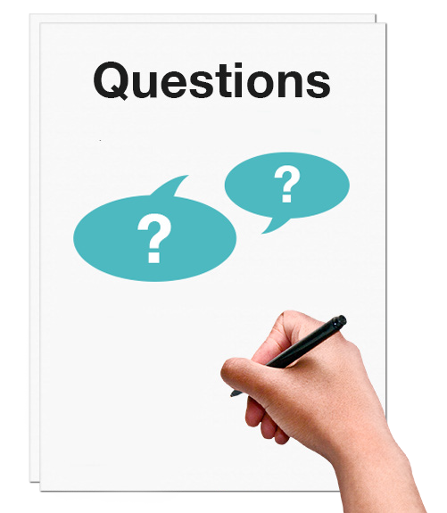We plan how we will do it. This could be things like
- Surveys

- Interviews

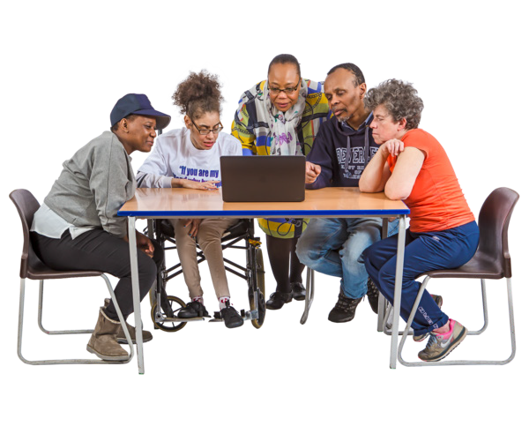We plan who will do the research.

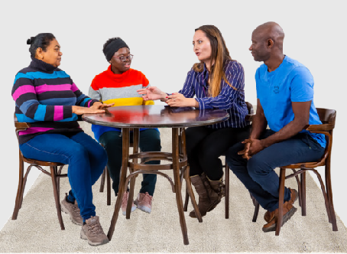
We plan how we will work together and what jobs everyone will do.

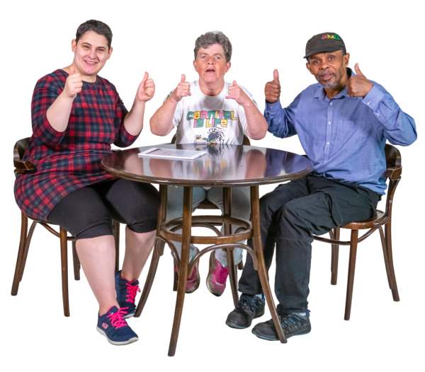We make sure everyone is safe and gets support.

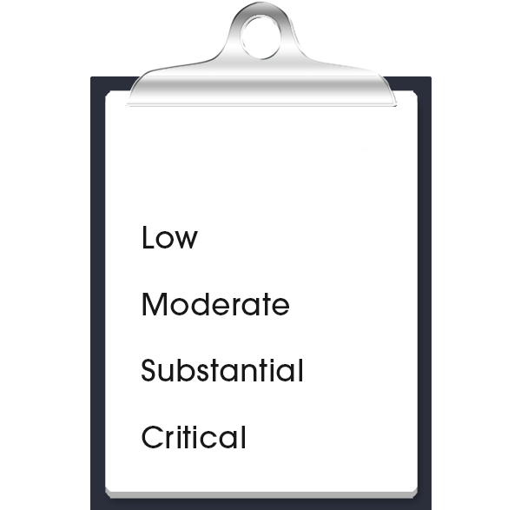Booklet 3 Doing research together

risk assessment

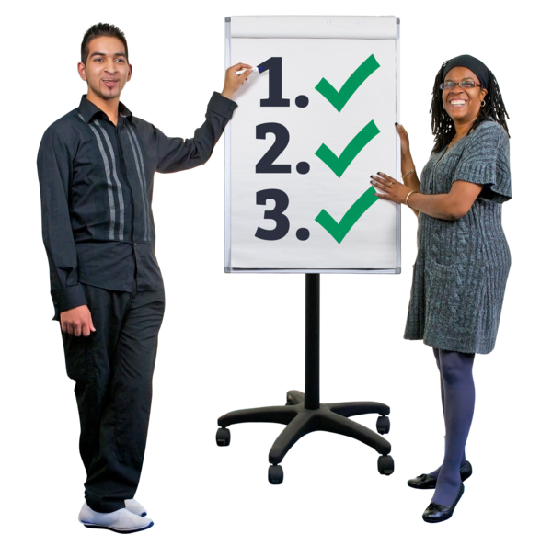Booklet 3 is called

Doing research together.

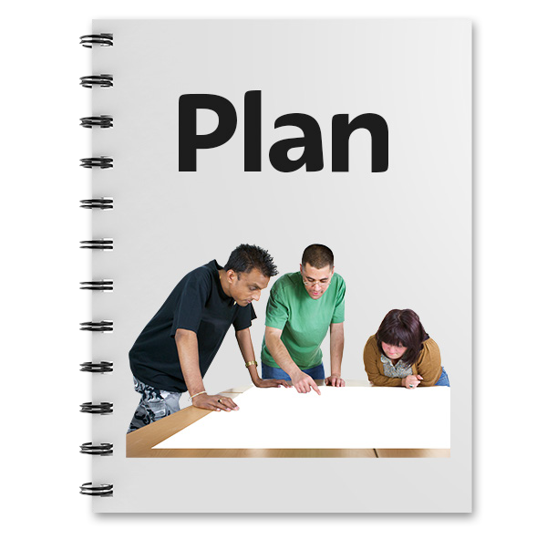In this step we start to do the things in our plan. This could be
- Finding people to do the research with

- Getting the information we need

- Doing things in an ethical way

Ethical means to make sure what we are doing is fair and does not hurt anyone.

We will do a risk assessment.

A risk assessment is a plan to keep everyone safe when we do the work.

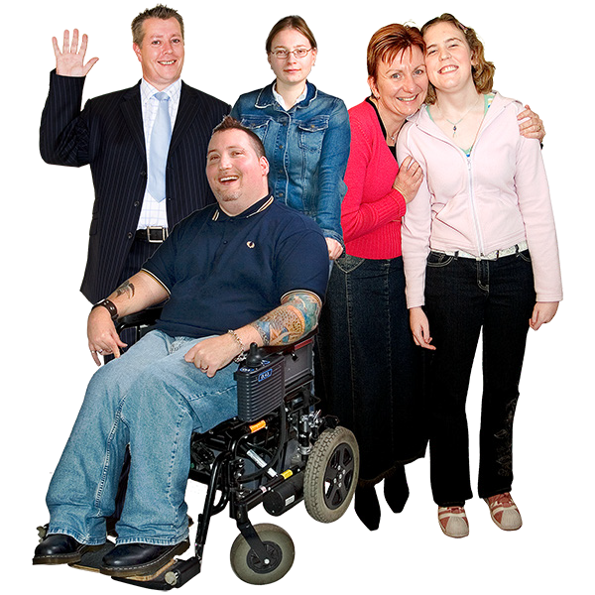We will choose what groups the research will be about.

We work with the groups to find people who we can ask our questions.

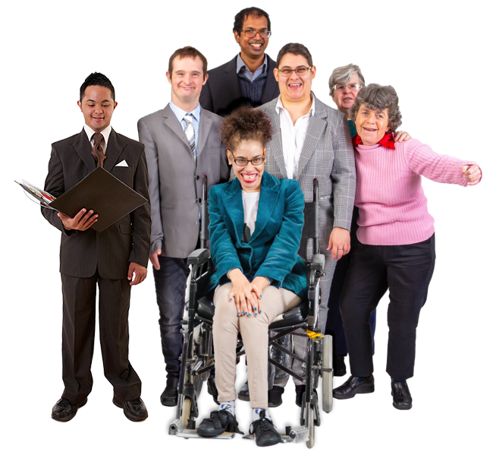We will go out into the community and get information.

This is called fieldwork.

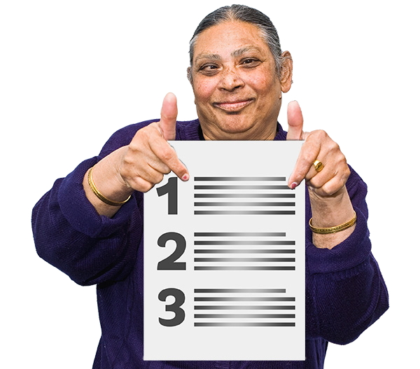We will use all of the information we get for our research.

Booklet 4 Understanding data together

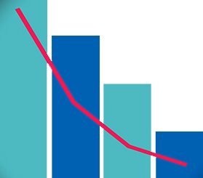Booklet 4 is called

Understanding data together.

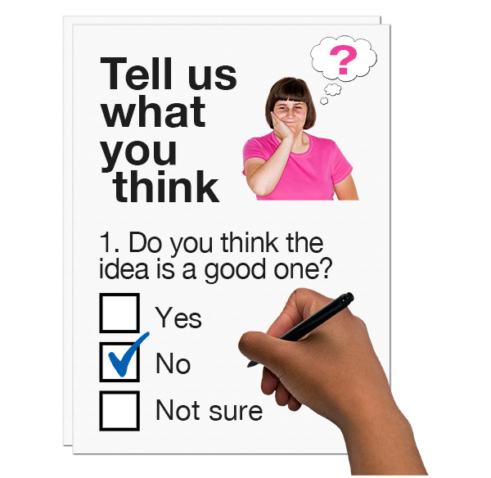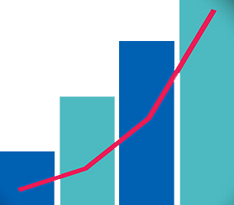Data is all the information we got in the step before.

This data could be what people said in surveys and interviews.

We look at our data to see if we understand how it fits in with our research plan.

We need to make sure we do things in a way that everyone can understand.

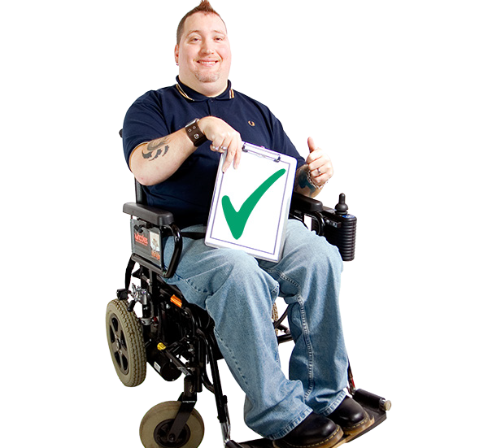We make sure co-researchers with disability look at the data.

This is so we can make sure the data will help people with disability.

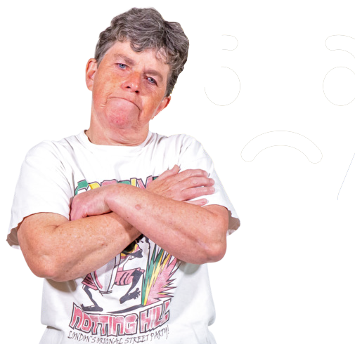Some co-researchers might get upset about some of the data.

The data could be about sad things.

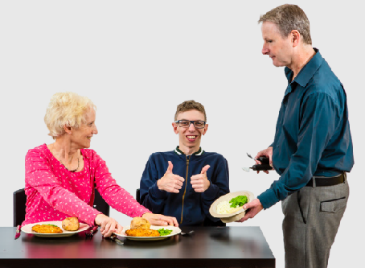
We will make sure everyone gets support and is safe.

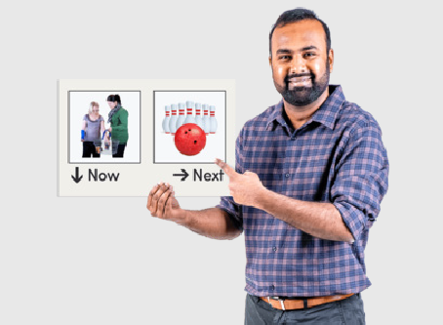
We need to think about how we can show the data and information in different ways.

We could

- Have short reports

- Use drawings and pictures

- Have focus groups

Booklet 5 Sharing what we learnt together

Booklet 5 is called

Sharing what we learnt together.

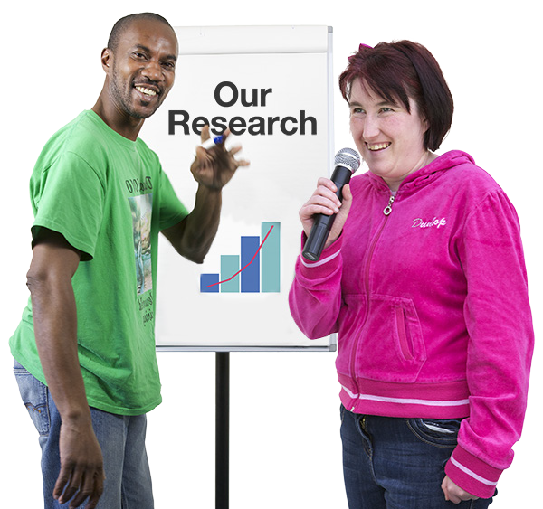In this step we need to share what we found out.

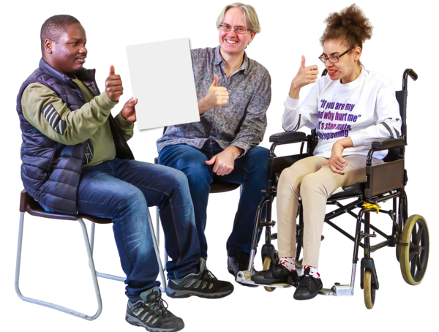We will choose together who we will share it with.

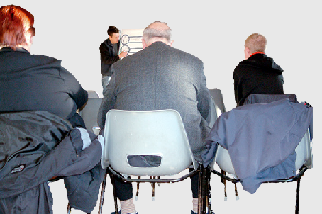
We will share what we found with a lot of people in the community.

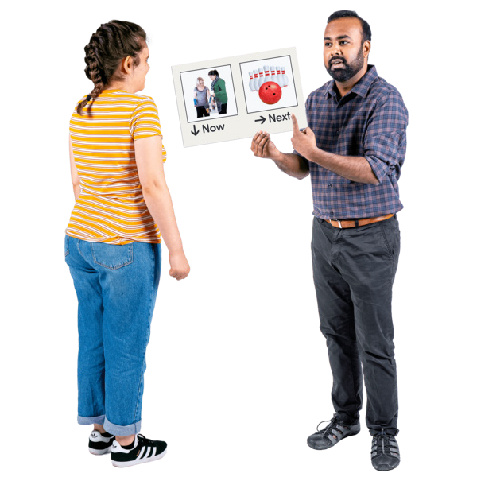We want to share what we found in a way that everyone understands.

This way we can share it with many
different people. 12

Booklet 6 Talking about our research together

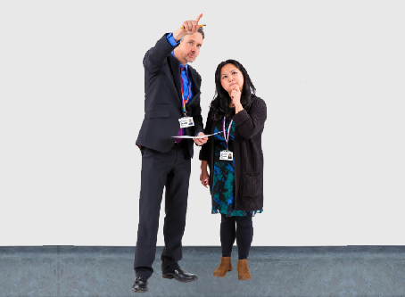
Booklet 6 is called

Talking about our research together.

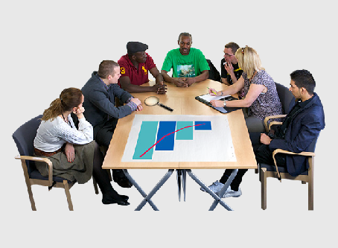
In this step we think about the research we did together.

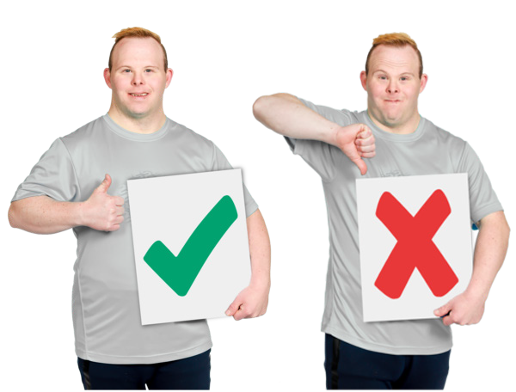We talk about

- What worked well

- What we can do better next time

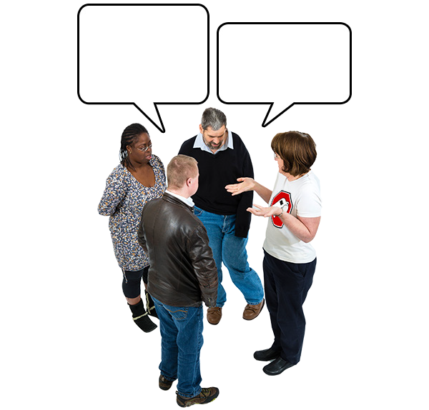It is good to tell others what we think and feel about what we did.

It will help us learn.

13

We need to think about how co-production helped with

- The project plan

- What we did

- Making good changes to research

When we work together we can talk about how things are going.

This will help us make things better along the way.

The things that we learnt can help other teams do co-research.

We have a booklet called Documents to help us do research together.
Documents to help us do research together

It has to do lists that can help us when we work together.

This guide was made by the Disability Innovation Institute at UNSW.
Council for Intellectual Disability made this document Easy Read. CID for short. You need to ask CID if you want to use any pictures in this document.
You can contact CID at business@cid.org.au 14

For more information contact:
15
Phone: 02 9385 9114
Email: diiu@unsw.edu.au
Website: www.disabilityinnovation.unsw.edu.au

