Participant Information Statement and Consent Form B – Easy Read
Stories of Change

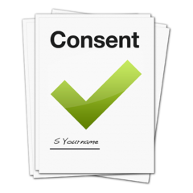

Evaluation of Community for Everyone
iRECS 8197 Reference
Version dated: 20 March 2025

Study about Community for Everyone
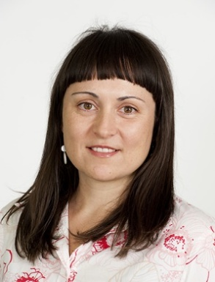
Hi, my name is name is Sandra
I am a researcher. My job is to find out things.
I do this by meeting with people and writing things down.
Karen Fisher, Sally Robinson, and Ricky Kremer are also in my research team.
New!
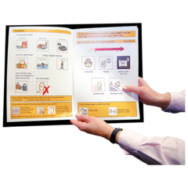
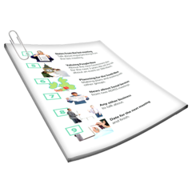
Community for Everyone wants to find out how people with disability and volunteers can do things together. How people can try new things, meet new people and make friends in the community.


I want to find out if Community for Everyone works well and how to make it better. This is called an evaluation.

We want to speak to people who are in Community for Everyone:
- People with disability
- who are 18 years and older

What happens in the study
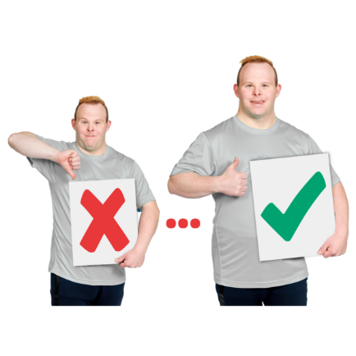
We want to find out about your experience of being in Community for Everyone.
What is good or bad, and how it has made a difference – friendships, doing things outside (community).


You choose how you share your story. You can speak to someone, write it down, make a video or photo, or drawing.


You can speak to a researcher (or someone you trust). They will ask you about your experience: what you do together, the places you go, and write it down.

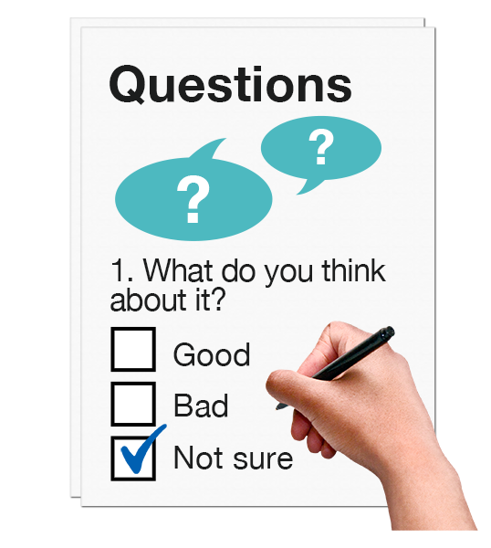
We would like to know:
  - the things you are interested in
  - things you do outside (in the community)
  - what has changed for you


You will receive a $50 gift card for your time.


You can take part if you want to.
You can say No. It’s your choice.
If you say no, no one will be upset and the support and relationships you have Community for Everyone will not change.
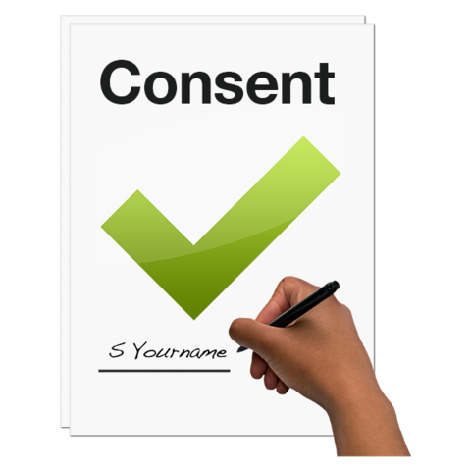

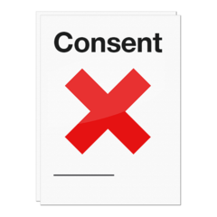
If you decide you want to take part, you can change your mind at any time and say No. Once you say no, we will remove anything you said or shared with us from our study records.

I will not tell people the names of you, where you live, or your friends.

If you want to take part in this study
If you want to take part, you will sign your name on the form that says, ‘I want to take part’.

That is on Page 7.

If you want to leave the study later, you can sign your name on the form that says ‘I changed my mind – I do not want to take part anymore’ or tell someone who will contact us.
That is on Page 8.


Thank you,
Sandra and the researchers

People to talk to about the research

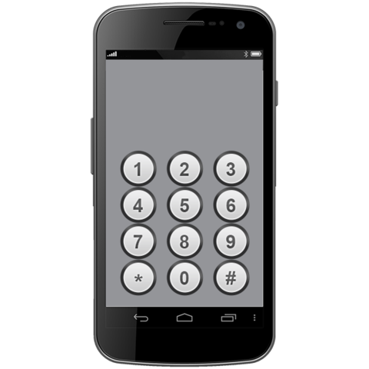
You can use the phone numbers and email addresses to ask people or complain about what we are doing.

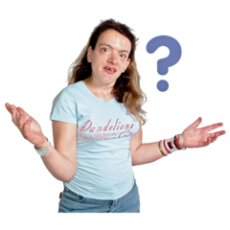
If you have questions about the research, you can talk to Karen Fisher at the University of New South Wales Karen.Fisher@unsw.edu.au or
(02) 9385 7813


If you want to complain about the research, talk with the Ethics Secretariat at the University of New South Wales at: humanethics@unsw.edu.au or
02 9385 6222.
Tell them this number iRECS 8197


If you feel sad or upset after answering the questions, you can call Lifeline Australia on 13 11 14 and they will talk with you.

Consent Form
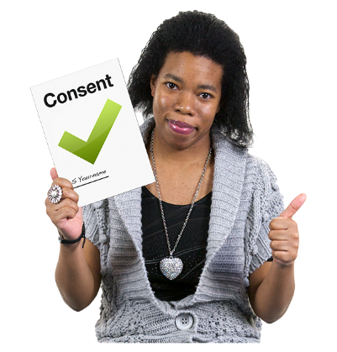
I want to take part in the research
I am signing this form because I want to take part in the study about Community for Everyone.
I understand that you will ask me questions about doing new things and making friends.
I can choose how I share my story (experience)
I understand you won’t tell anyone my name.
I understand that I can change my mind later (withdraw from the study).

........................................................  My signature  Date: ……. / ……./ …… | ........................................................  My name
........................................................  Researcher’s signature  Date: ……. / ……./ …… | ........................................................  Full name
I changed my mind – I do not want to take part anymore
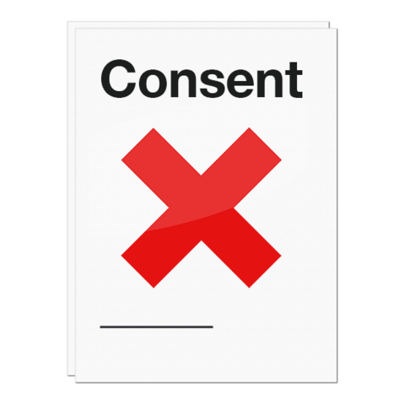
Sign this form and send to: Karen.Fisher@unsw.edu.au
☐ I am signing this form as I changed my mind.
☐ I do not want to take part in the study.
☐ I do not want you to use what I said.
........................................................  My signature | ........................................................  Signature of someone who saw me  sign the form
........................................................  Write your name here | ........................................................  Write their name here
........................................................  Date | ........................................................  Write how they know you

